**Interim Report**

**Level 02**

**Expense Tracker System**

Team ToDo

|  |  |
| --- | --- |
| Wickramasingha W.U.M. | 214228B |
| Wijesinghe W.D.A.C. | 214235T |
| Senarathna G.G.P.C. | 214189E |
| Priyashan H.M.L.S. | 214162P |
| Karunarathna W.M.W.G.M.S. | 214101F |

Faculty of Information Technology

University of Moratuwa

2023

**Interim Report**

**Level 02**

**Expense Tracker System**

Team ToDo

|  |  |
| --- | --- |
| Wickramasingha W.U.M. | 214228B |
| Wijesinghe W.D.A.C. | 214235T |
| Senarathna G.G.P.C. | 214189E |
| Priyashan H.M.L.S. | 214162P |
| Karunarathna W.M.W.G.M.S. | 214101F |

**Supervised by:** Ms. R.G.C. Upeksha

Faculty of Information Technology

University of Moratuwa

2023

**Abstract**

This project aims to develop an innovative Expense Tracker System website, offering users a comprehensive and user-friendly platform to manage and monitor their finances effectively. The system will provide a streamlined interface for recording expenses, categorizing transactions, generating insightful reports, and setting budgetary goals. Leveraging modern web technologies, the website will prioritize security, accessibility, and ease of use, empowering individuals and businesses to gain better control over their financial activities. Through intuitive design and robust functionalities, this Expense Tracker System seeks to revolutionize personal and organizational expense management, fostering financial awareness and responsible spending.

Considering those requirements, we are designing a system that facilitates all the requirements as a Progressive Web Application (PWA). Users who want to track their financial circumstances.

To provide a better application we analyze our customer requirements and design the unified model language diagrams before implementation. For developing our system, we chose technologies after a better research program. ReactJS for the frontend, ASP.NET for the backend, and MS SQL for the data management system of our system.

**Chapter 1 Introduction**

**1.1 Introduction**

Expense tracking is a crucial part of financial management, helping you understand your spending habits and make informed decisions. Common methods for tracking expenses include manual methods like pen and paper or spreadsheet software, as well as digital solutions such as mobile apps, online platforms, and dedicated software. Key elements to record include the date, description, category, amount, payment method, and receipts.

By consistently tracking your expenses, you can gain insights into where your money goes, allowing you to create a budget, cut unnecessary expenses, and work towards your financial goals. Whether you prefer traditional methods or modern digital tools, finding a tracking method that suits your lifestyle is essential for effective financial management. More than just a tool for record-keeping, this system aspires to become an indispensable companion in fostering financial awareness, encouraging responsible spending, and facilitating informed decision-making. Through meticulous attention to detail and a commitment to user needs, this Expense Tracker System project endeavors to redefine the standards of financial management, setting a new paradigm for efficiency, accessibility, and financial well-being.

**1.2 Background and Motivation**

Expense tracking is vital for financial management. However, it can be challenging due to various factors. Manual tracking with pen and paper or spreadsheets often results in incomplete records and forgotten expenses. Bank statements offer convenience but lack transaction details and categorization. Additionally, the increasing use of mobile apps raises privacy concerns, as these apps may access sensitive financial information.

The genesis of the Expense Tracking System emerged from a critical observation of the challenges individuals and organizations face in managing their financial records effectively. In a fast-paced, digitally-driven world, the complexity of financial transactions often leads to scattered records, hindering a clear overview of expenditure and revenue streams. The motivation stemmed from a desire to alleviate the burden of manual record-keeping, offer a centralized platform for financial data, and provide users with actionable insights to make informed financial decisions. Moreover, considering the dynamic nature of today's economy, the need for a robust, user-friendly system to monitor expenses, set budgets, and track financial goals became apparent. This system aims not only to streamline financial management but also to empower users with the knowledge and tools to navigate their financial landscapes confidently. The goal is to revolutionize how individuals and businesses interact with their finances, promoting financial stability, and fostering a culture of informed financial management.

Furthermore, some individuals find it easier to overspend when using digital tracking methods. Balancing convenience with accuracy and privacy is essential for effective expense tracking.

**1.4 Aim and Objectives**

**Aim:**

To develop an Expense Tracking System to track users’ financial performance and get a proper idea about their financial requirements.

**Objectives:**

* To make user authentication and authorization for all the users.
* Design the appropriate system including all user requirements.
* Keep records of users’ expenses and incomes.
* To get their financial reports.
* Create savings and budget plans.
* Develop the system for solving the problem.
* Evaluation of the proposed solution.
* Preparation of final documentation.

**1.4 Problem in brief**

The problem with expense tracking lies in incomplete data, forgotten transactions, and inconsistent categorization. Manual methods are time-consuming while relying solely on bank statements lacks detail. Privacy concerns and the risk of overspending through mobile apps further complicate the process.

**1.5 Summary**

Through Chapter 1 of this report, we provide a basic introduction to the Expense Tracker System that we expect to develop. It outlines the system's purpose in revolutionizing expense monitoring, budgeting, and financial decision-making for both individuals and organizations. In the next chapter, similar projects for this project will be mentioned and discussed the differences between those projects and ours.

**Chapter 2 Existing Solutions**

**2.1 Introduction**

Chapter 2 focuses on documenting the different approaches to addressing the same problem which this application selected to offer a solution for. In the modern world, the Expense Tracker System is useful for individuals and organizations. Furthermore, there are many applications dedicated to Expense Tracker System in the world too. This chapter describes related products in the market same as the proposed solution.

**2.2 Similar Products**

The software listed below can be identified as similar solutions that directly focus on some of the areas of our problem to be solved.

**2.2.1 Monefy**

Monefy is an expense tracking system application used mostly by individuals. It is a personal finance application that makes money management easy. The app is designed to streamline expense tracking and help you save money. It can create categories and start tracking essential expenses.

But Monefy can’t be used for advanced financial analysis. It has some syncing issues , security concerns, and limited integrations.

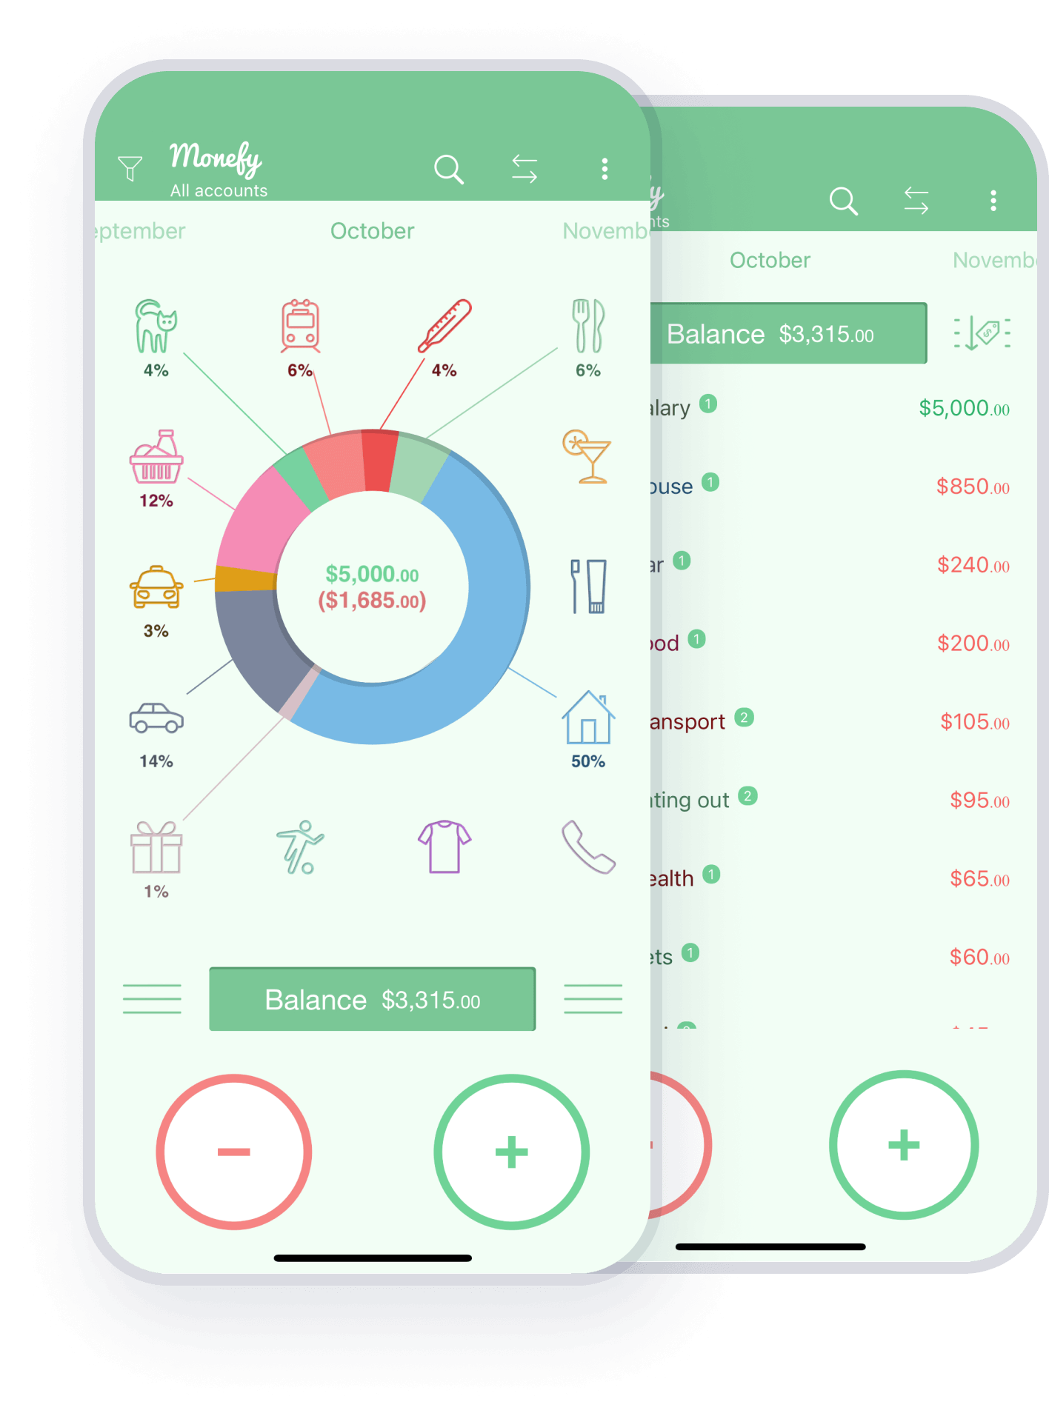

*Figure 01: Monefy*

**2.2.2 Expensify**

Expensify is a popular expense management software designed to streamline the process of expense reporting, tracking, and reimbursement for individuals, small businesses, and larger enterprises. Here are some key features and descriptions of Expensify,

* Expense Tracking
* Receipt Capture
* Automated Reporting
* Advanced Features for Businesses

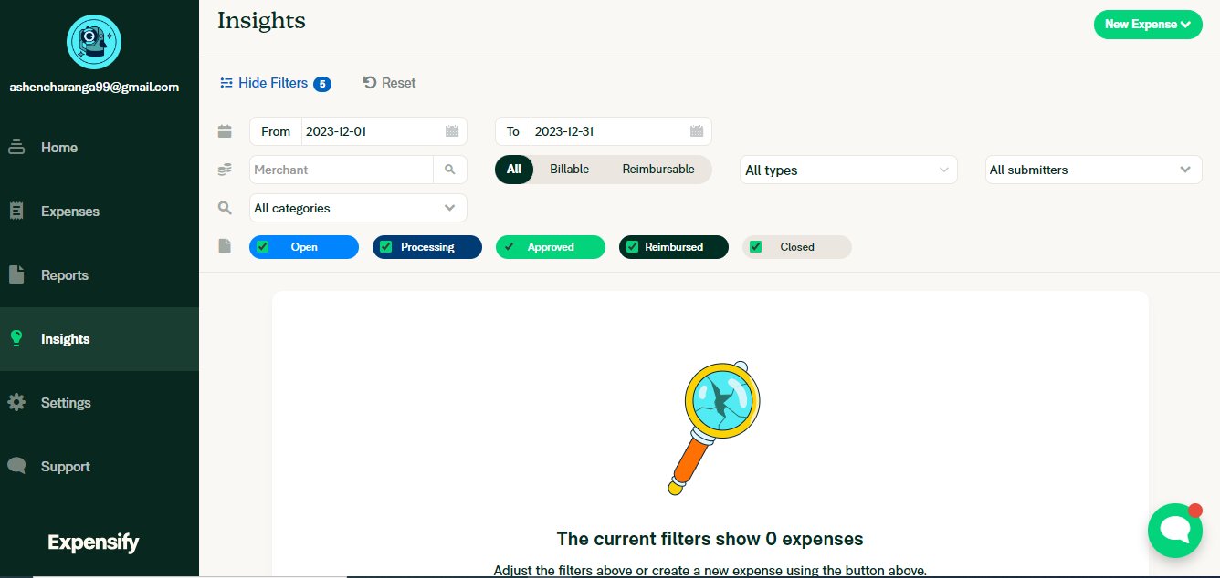

*Figure 02: Expensify*

**2.2.3 mint**

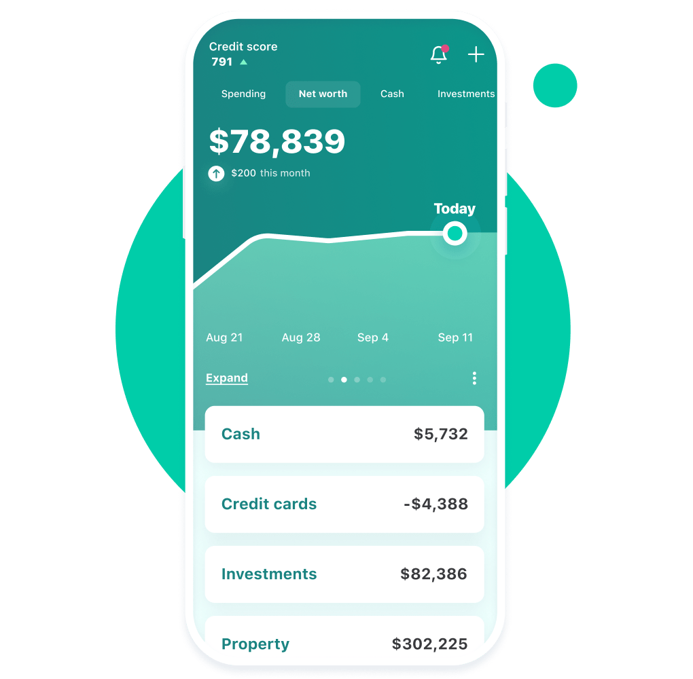 *Figure 03: mint*

Mint is a widely used personal finance management website that offers comprehensive tools for expense tracking, budgeting, and financial planning. It has some key features like Real-Time Expense Tracking, Budgeting Tools, and Bill Payment Reminders. While Mint offers numerous advantages in expense tracking and financial management, there are some limitations or drawbacks users might encounter that are security concerns, lack of investment tracking, etc.

**2.3 Summary**

So, according to the above solutions, there are similar features and drawbacks in each tracking system. Therefore, we are considering our system demonstrates the following unique features,

* Very simple user interface.
* Report generation and result dashboard.
* Create Savings and budget plans.
* Create upcoming payment reminders.

It gives an insight into the customer needs and preferences.

**Chapter 3 Technologies Adapted**

**3.1 Introduction**

To build the proposed solution, various technologies are used. They can be divided into the following categories.

* Front-end technology
  + React JS
* Back-end technology
  + MS .net framework
* Database technology
  + MS SQL Server

**3.2 Front-end technology**

The front-end is the interfaces within the proposed system. And this is the point at which end users engage with the system. The system needs to provide a better user experience through interfaces from the viewpoint of the end user. Therefore, we have selected React JS to develop the front-end.

**3.2.1 React JS**

React is a popular JavaScript library for building user interfaces, particularly web-based applications. It is often used for front-end development because it allows developers to create reusable components that can be rendered on the page, making it easier to build and maintain complex user interfaces. Since the proposed system is CRM software, there are so many individual sections that should be attached together and reused. The functionality of React may be a huge advantage while the development of front-end.

One of the key benefits of React is that it uses a virtual DOM (Document Object Model). Therefore, when data in a React application changes, the virtual DOM will determine the minimal set of changes that need to be made to the actual DOM. This could lead the application to improve the performance.

React also has a strong developer community, with a wealth of resources and libraries available to help developers build and maintain their applications. Since the team members do not have a lot of experience of building front ends and using react for development, this can be a main benefit for the team.

Due to the efficiency, flexibility, and strong developer community of React, it is easier to build the front-end of the proposed system.

**3.3 Back-end technology**

All the functionalities of the proposed system are within the back-end development. And it is the core of the application. Therefore, back-end technology is selected carefully. That is why Microsoft .net Framework is selected to build the back end of the system.

**3.3.1 MS .net framework**

The .NET framework is a popular choice for back-end development because it provides a powerful platform for building and running web-based applications and services. Also, it is flexible and scalable, allowing developers to build applications for a wide range of environments and platforms.

One of the key benefits of the .NET framework is that it provides a large set of libraries and APIs that developers can use to access a variety of different services and resources. This includes support for networking, data access, security, and many other common backend tasks.

The .NET framework also includes several tools and technologies that make it easier for developers to build and maintain applications, including a powerful runtime environment, a comprehensive set of development tools, and a large and active developer community.

**3.4 Database Technology**

The database can be identified as a major entity of the system. A database is typically designed to store and access data. A well-designed database is crucial to the system since the database stores all the relevant insights regarding the system. To develop such a database, the team has decided to use Microsoft SQL server as the technology.

**3.4.1 Microsoft SQL server**

SQL server has been introduced and maintained by Microsoft so far. Because of its popularity and many other facts, it is widely used as a Database Management System (DBMS) by many developers. Also, it is compatible with .net framework too.

Some of the features of SQL server are,

**Reliability:** Reliability and uptime of SQL server is making it an excellent choice for mission-critical applications that require a high level of availability.

**Performance:** SQL Server is designed to handle large volumes of data and transactions, and it is optimized for fast and better performance.

**Security:** There are many security features to protect data from unauthorized access, such as encryption, authentication, and access controls within SQL servers.

**Scalability:** This allows us to handle increasing amounts of data and workloads as the needs of the application grow.

**Management:** Handy features like backup and recovery, monitoring, and performance tuning can be used within SQL server

**Chapter 3 Proposed Solution**

**4.1 Introduction**

**Chapter 5 Analysis and Design**

**5.1 Class Diagram**

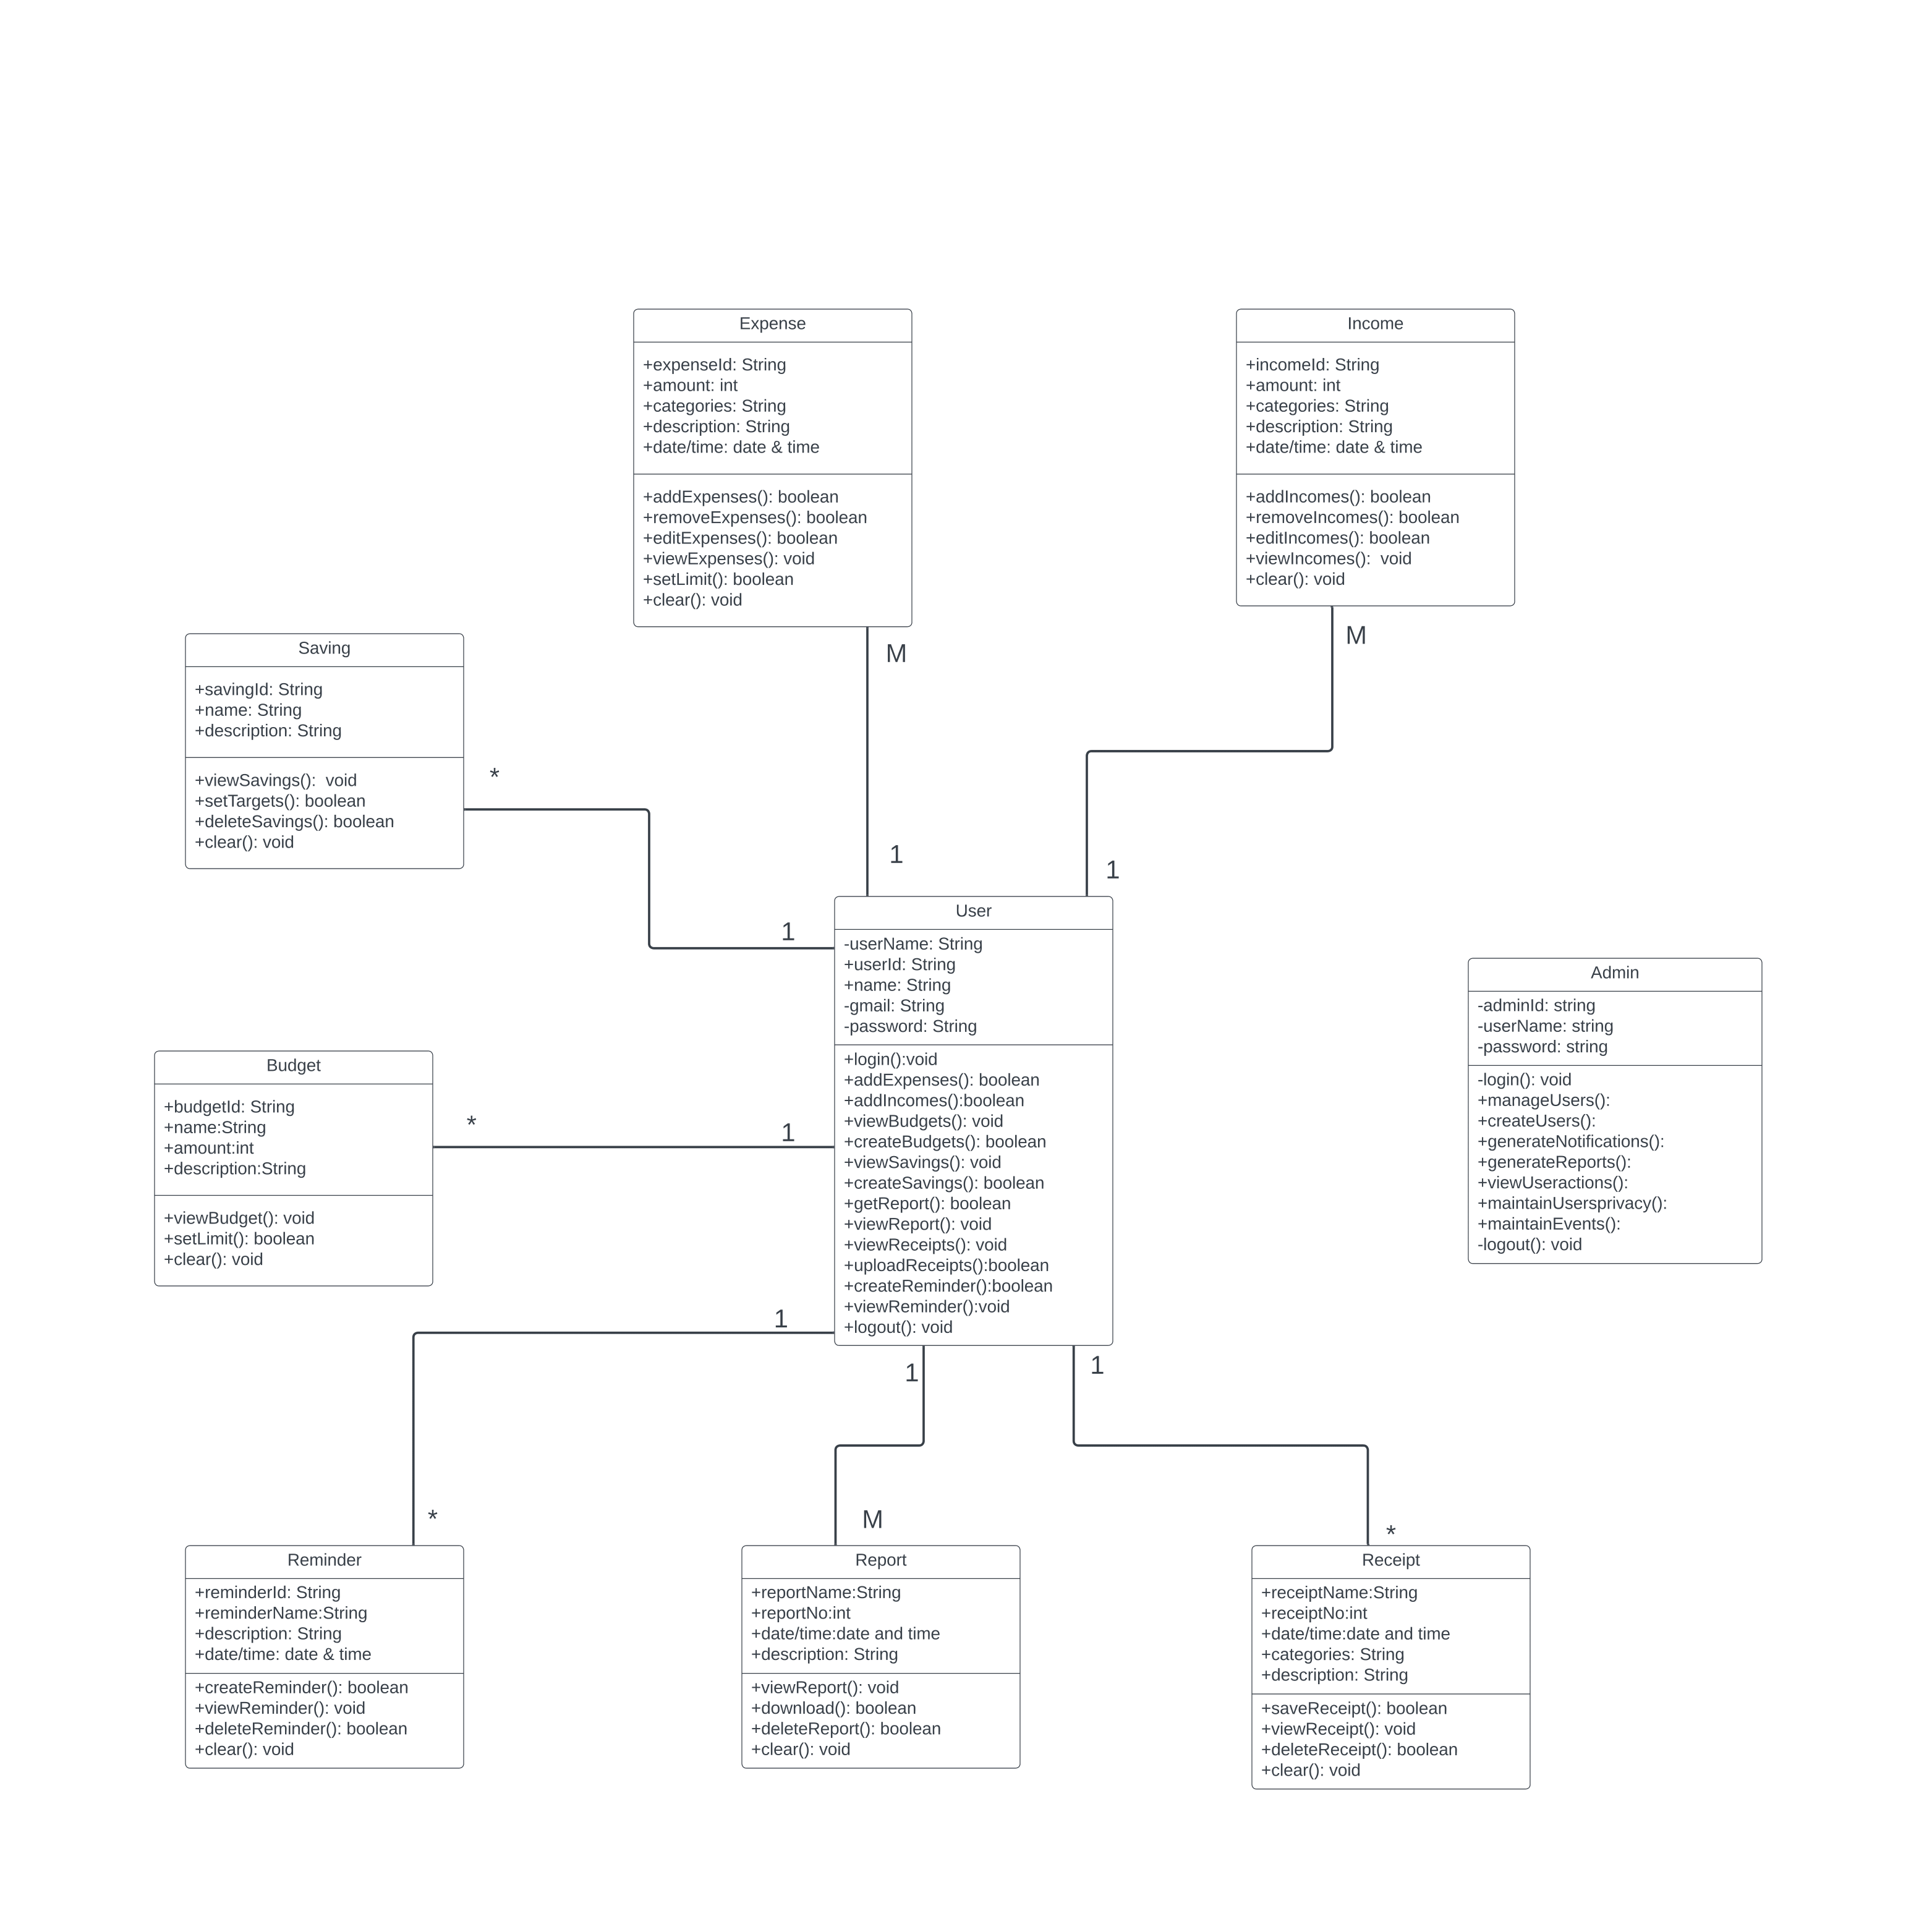

*Figure 04: Class diagram*

**5.2 Use case Diagram**

*Figures 05 & 06: Use case diagram*

**5.3 Activity Diagrams**

**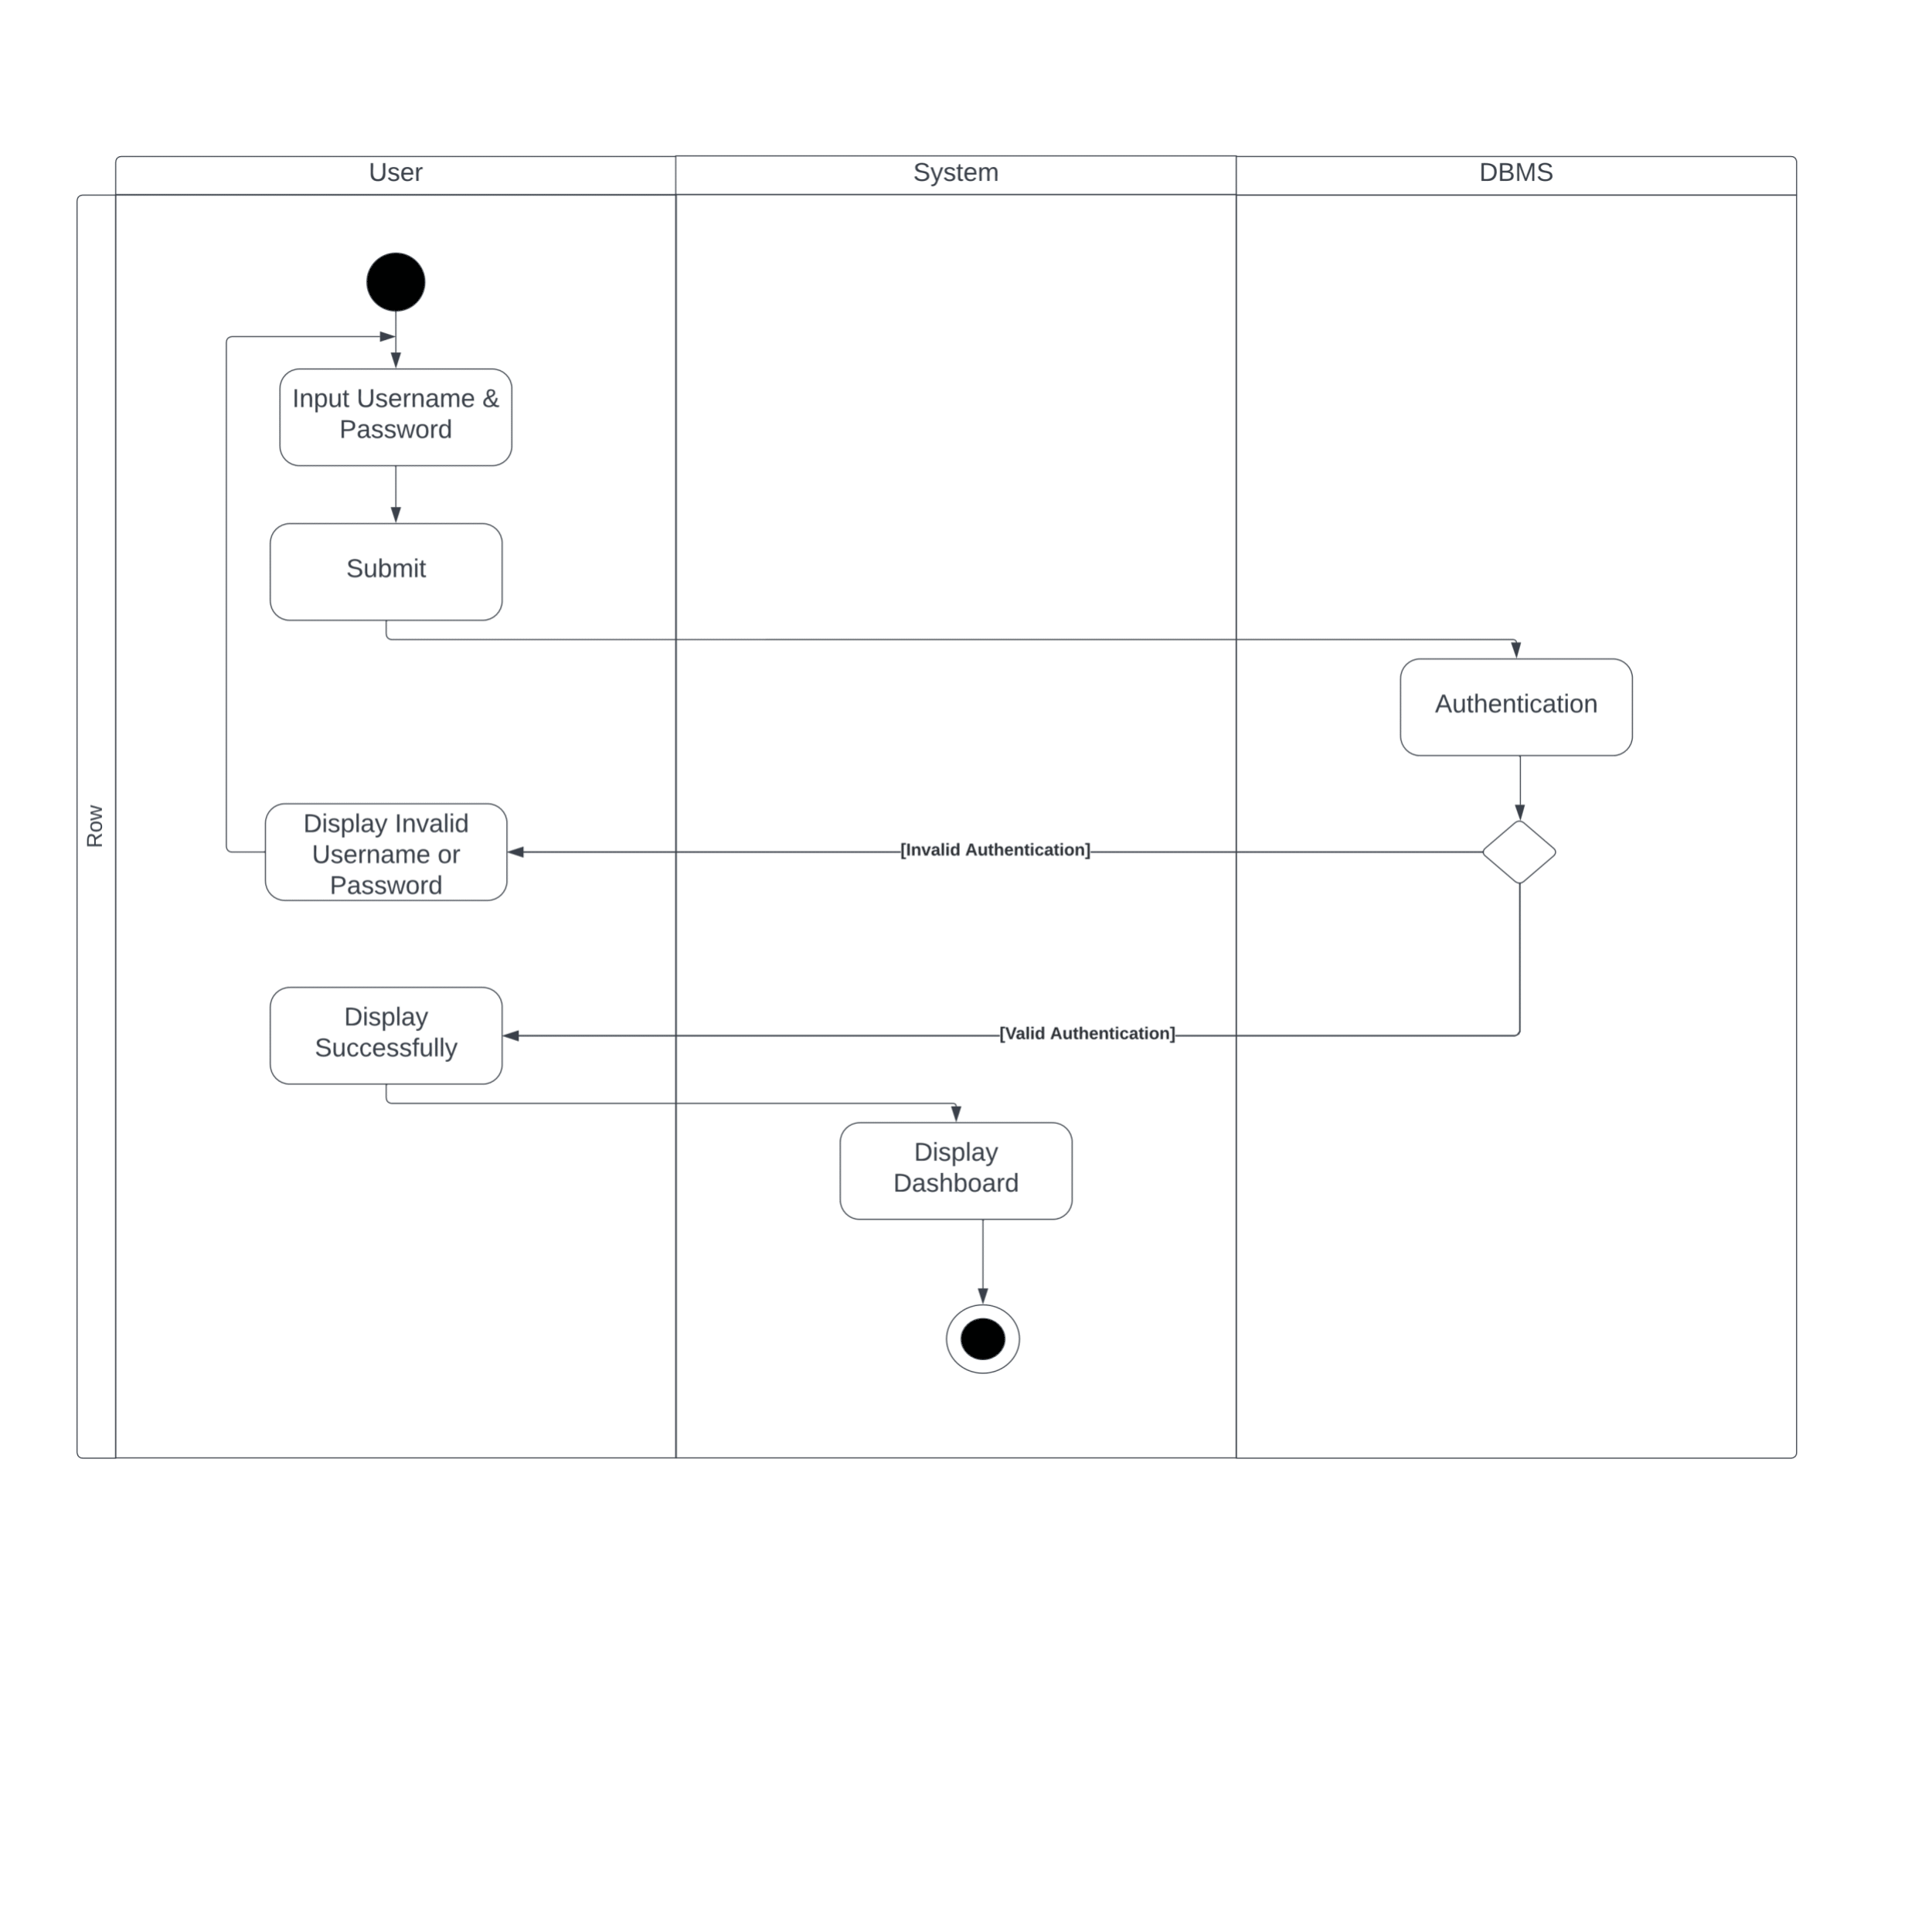***Figure 07: Activity diagram – Login*

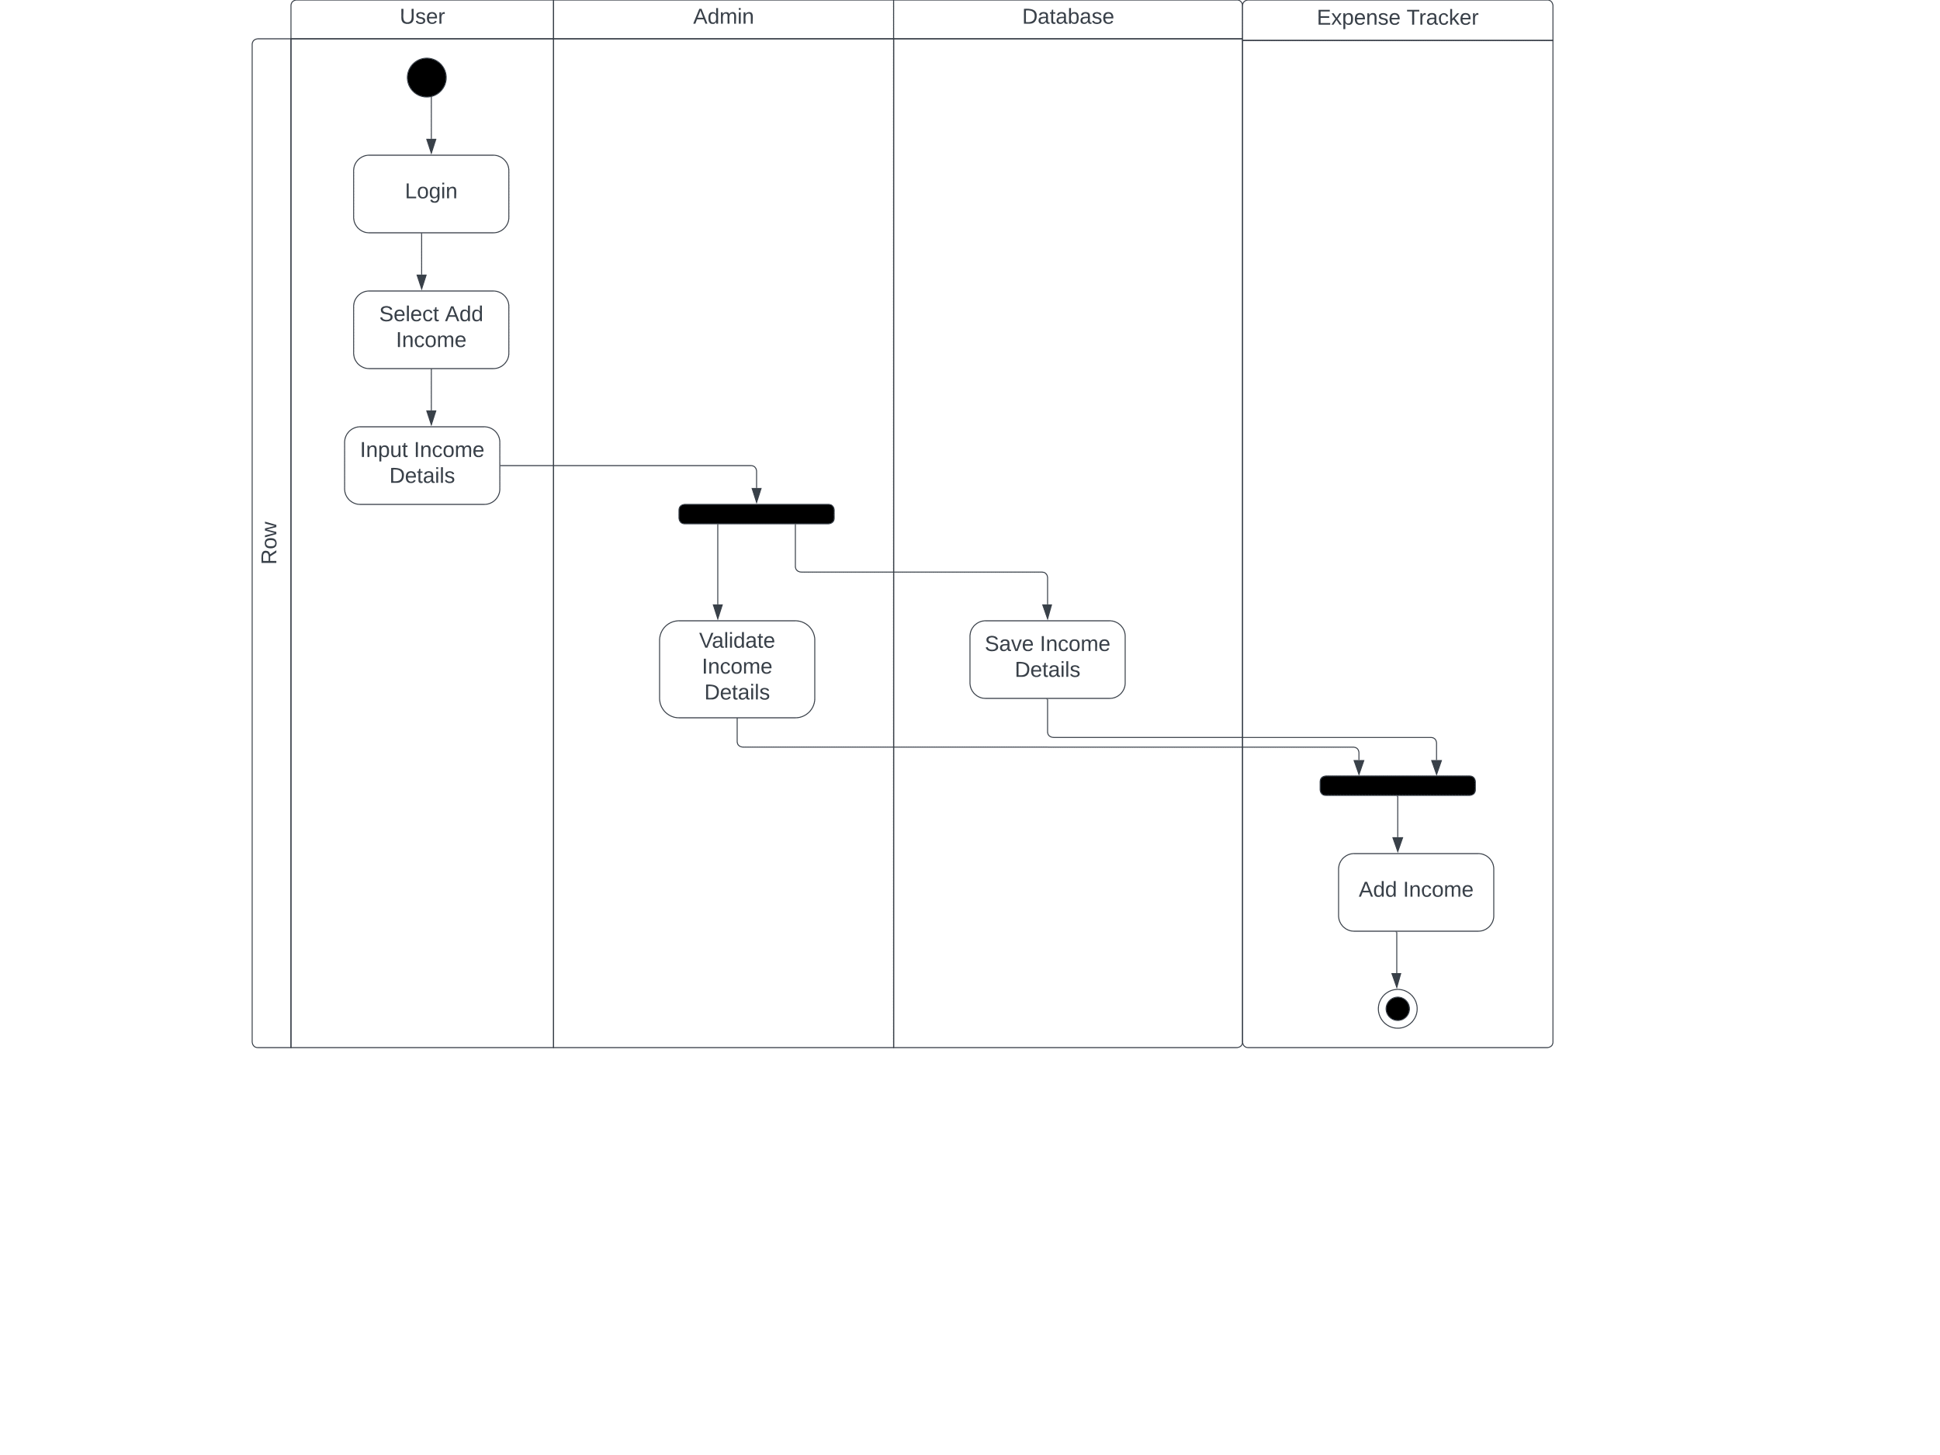

*Figure 08: Activity diagram – Add income*

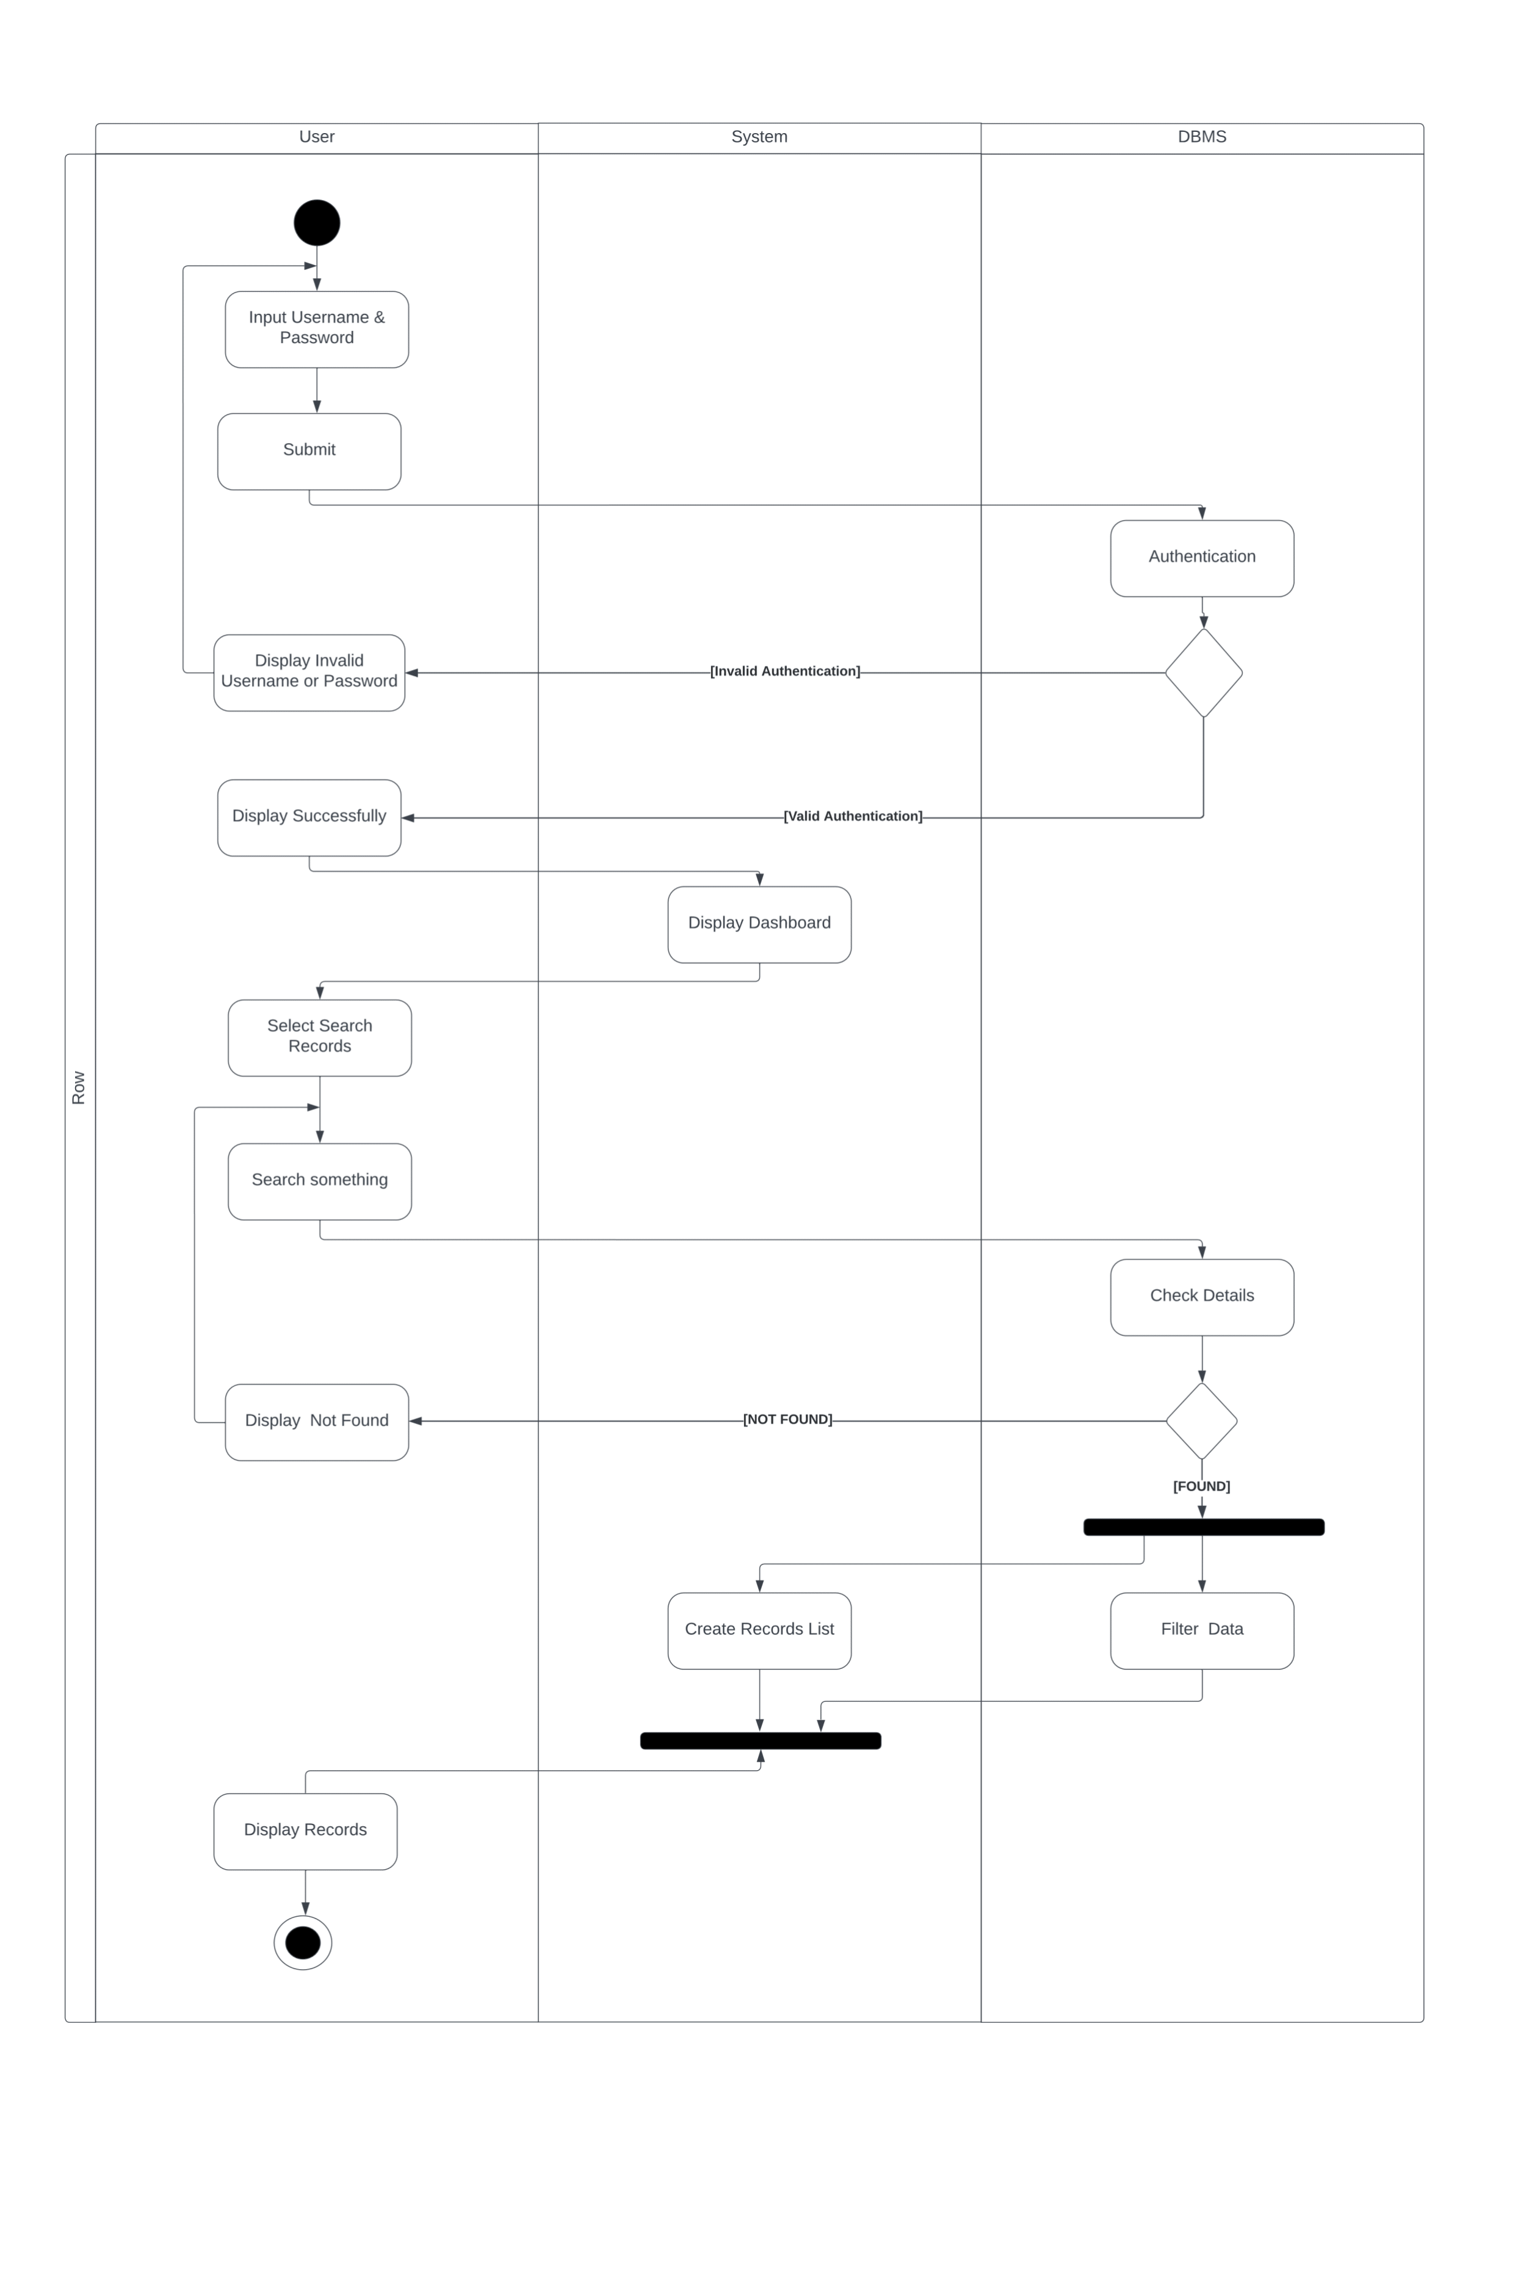

*Figure 09: Activity diagram – Search records*

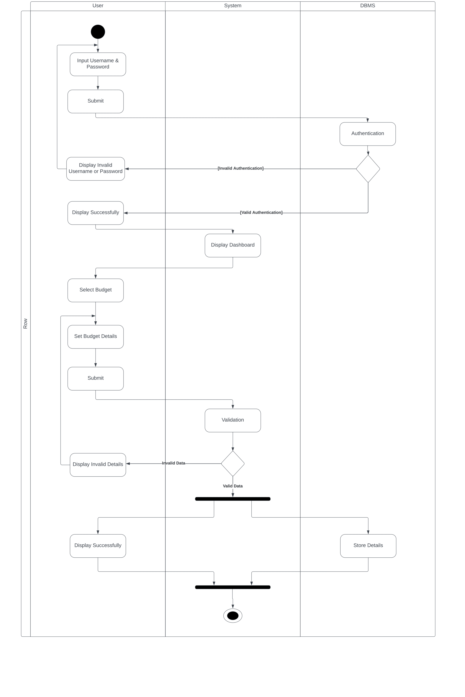

*Figure 10: Activity diagram – Create budgets*

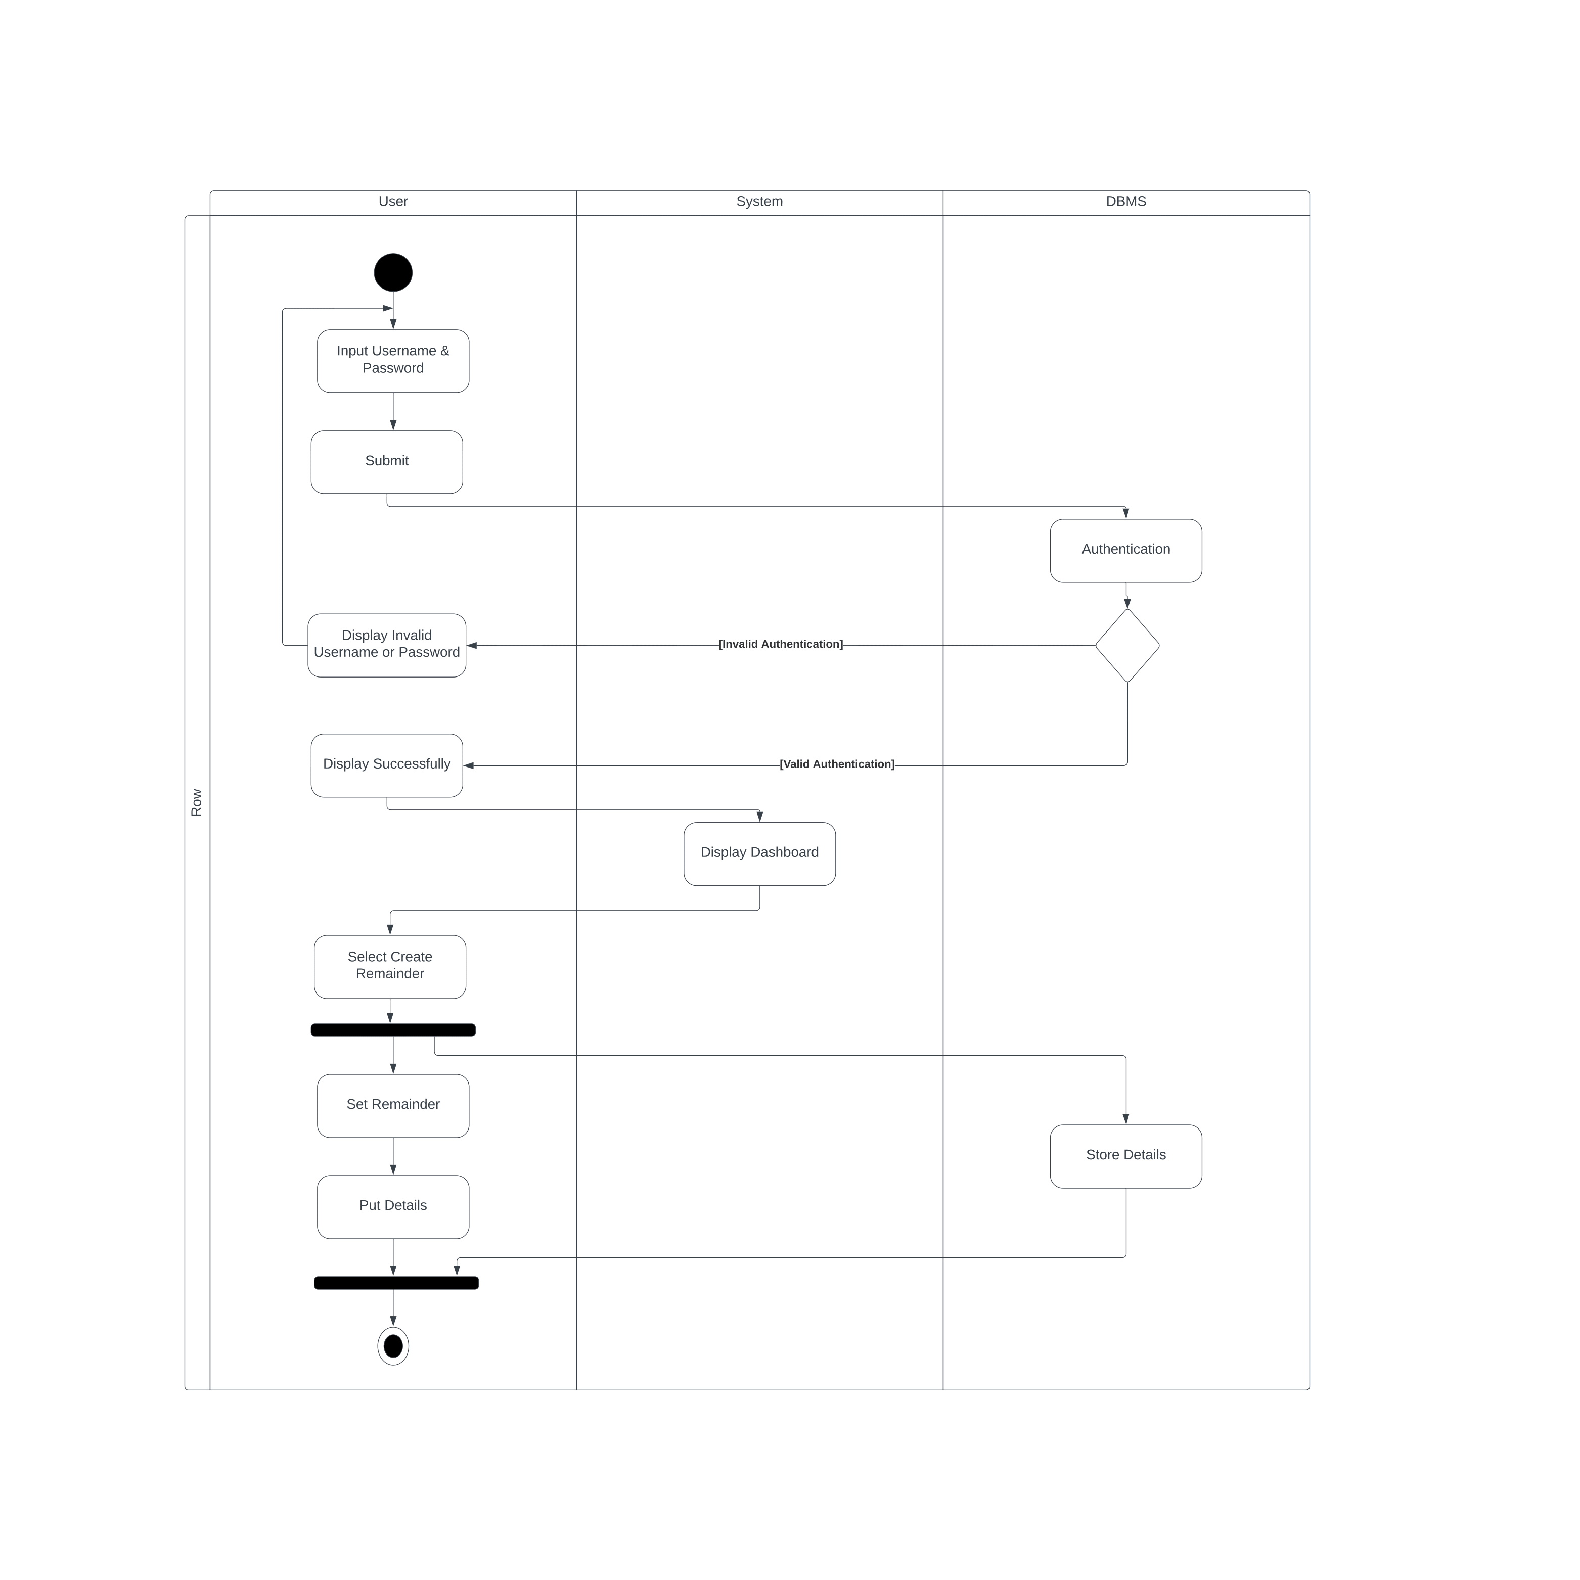

*Figure 11: Activity diagram – Create reminder*

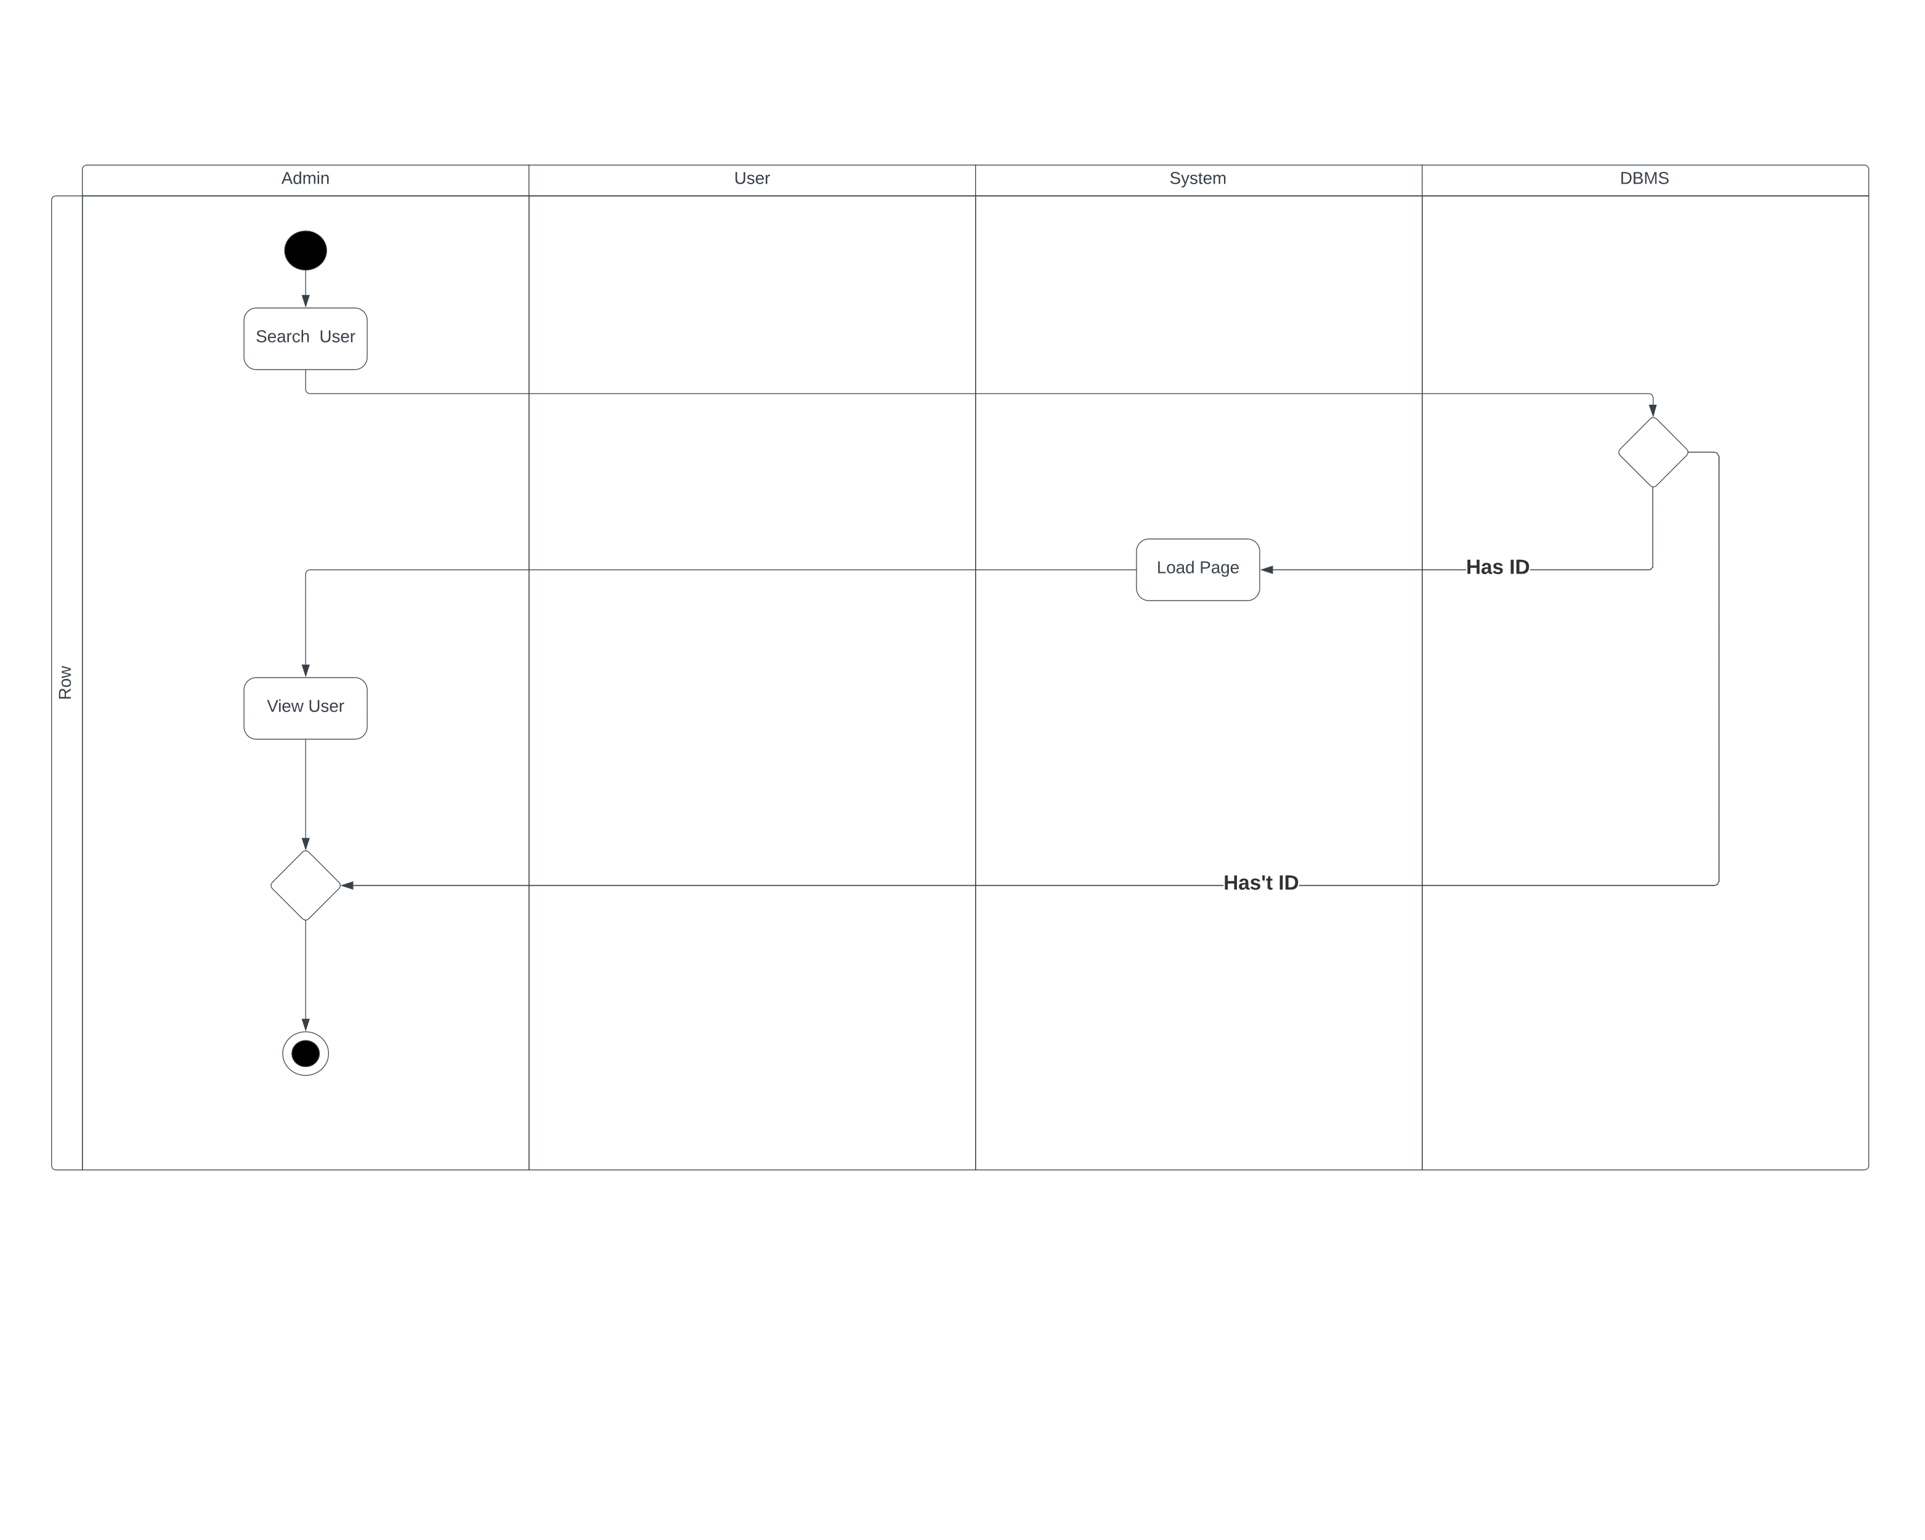

*Figure 12: Activity diagram – Search user*

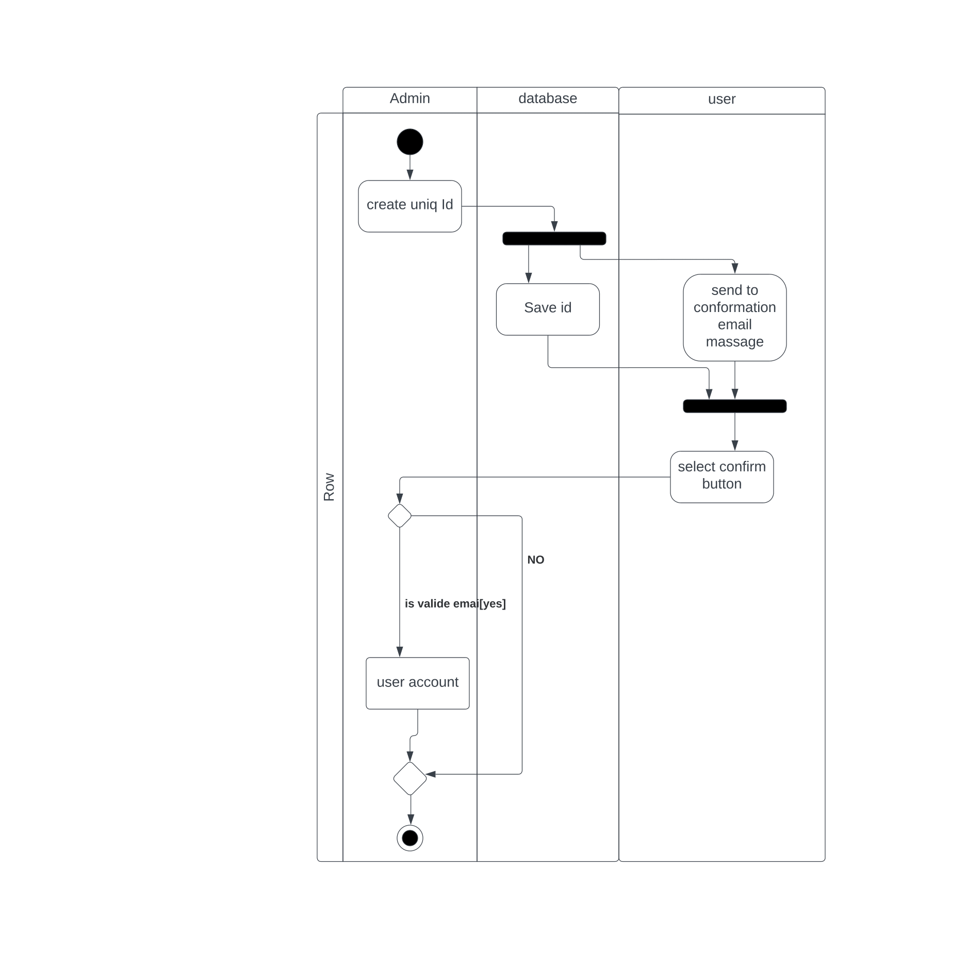  
*Figure 13: Activity diagram – Create user Figure 14: Ac diagram – Upload receipt*

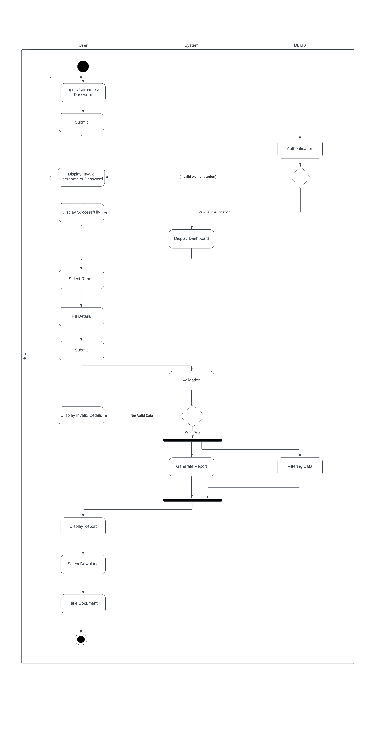

*Figure 14: Activity diagram – Download report*

*Figure 14: Activity diagram – Send alert*

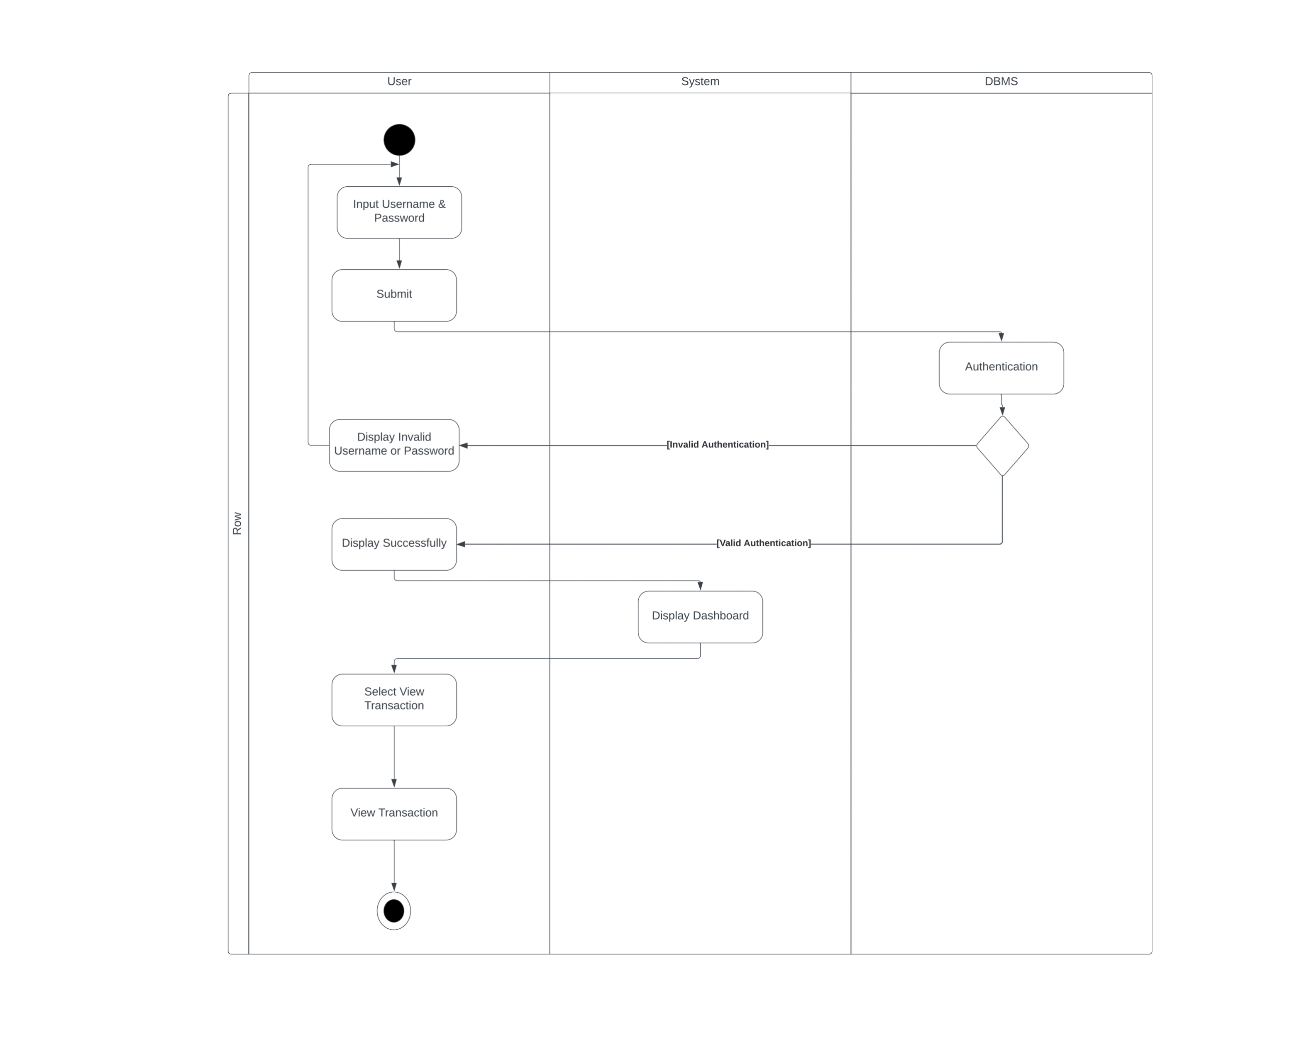

*Figure 15: Activity diagram – View transaction*

*Figure 16: Activity diagram – Create savings*

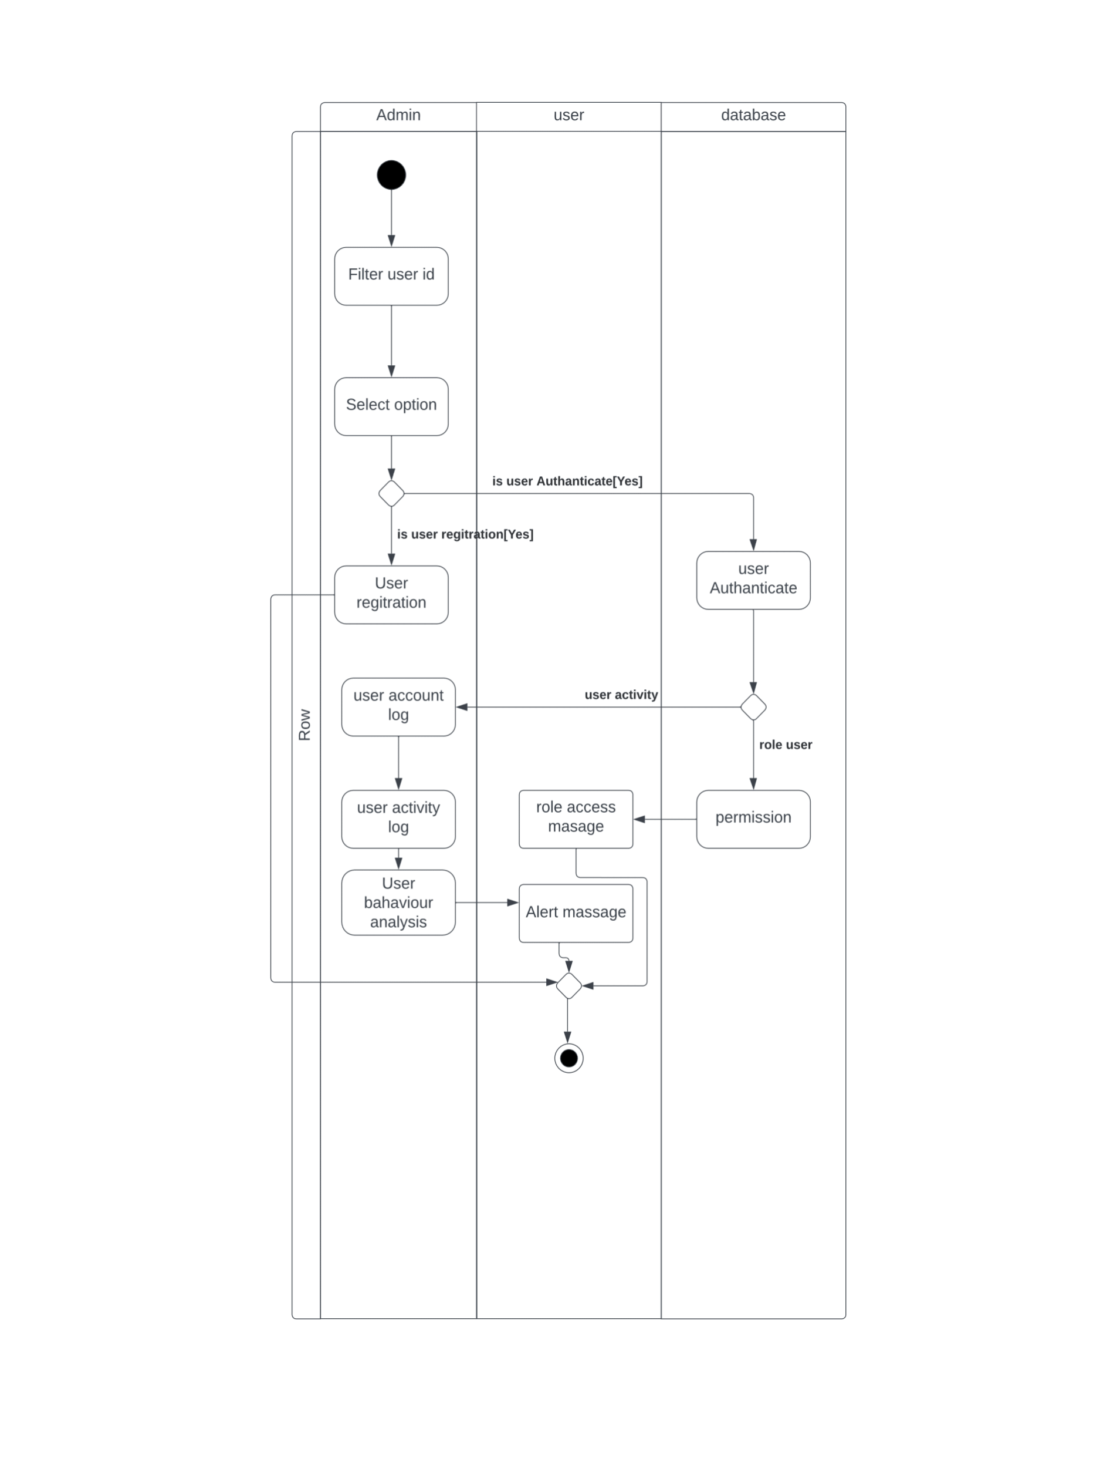

*Figure 17: Ac diagram – Manage user*

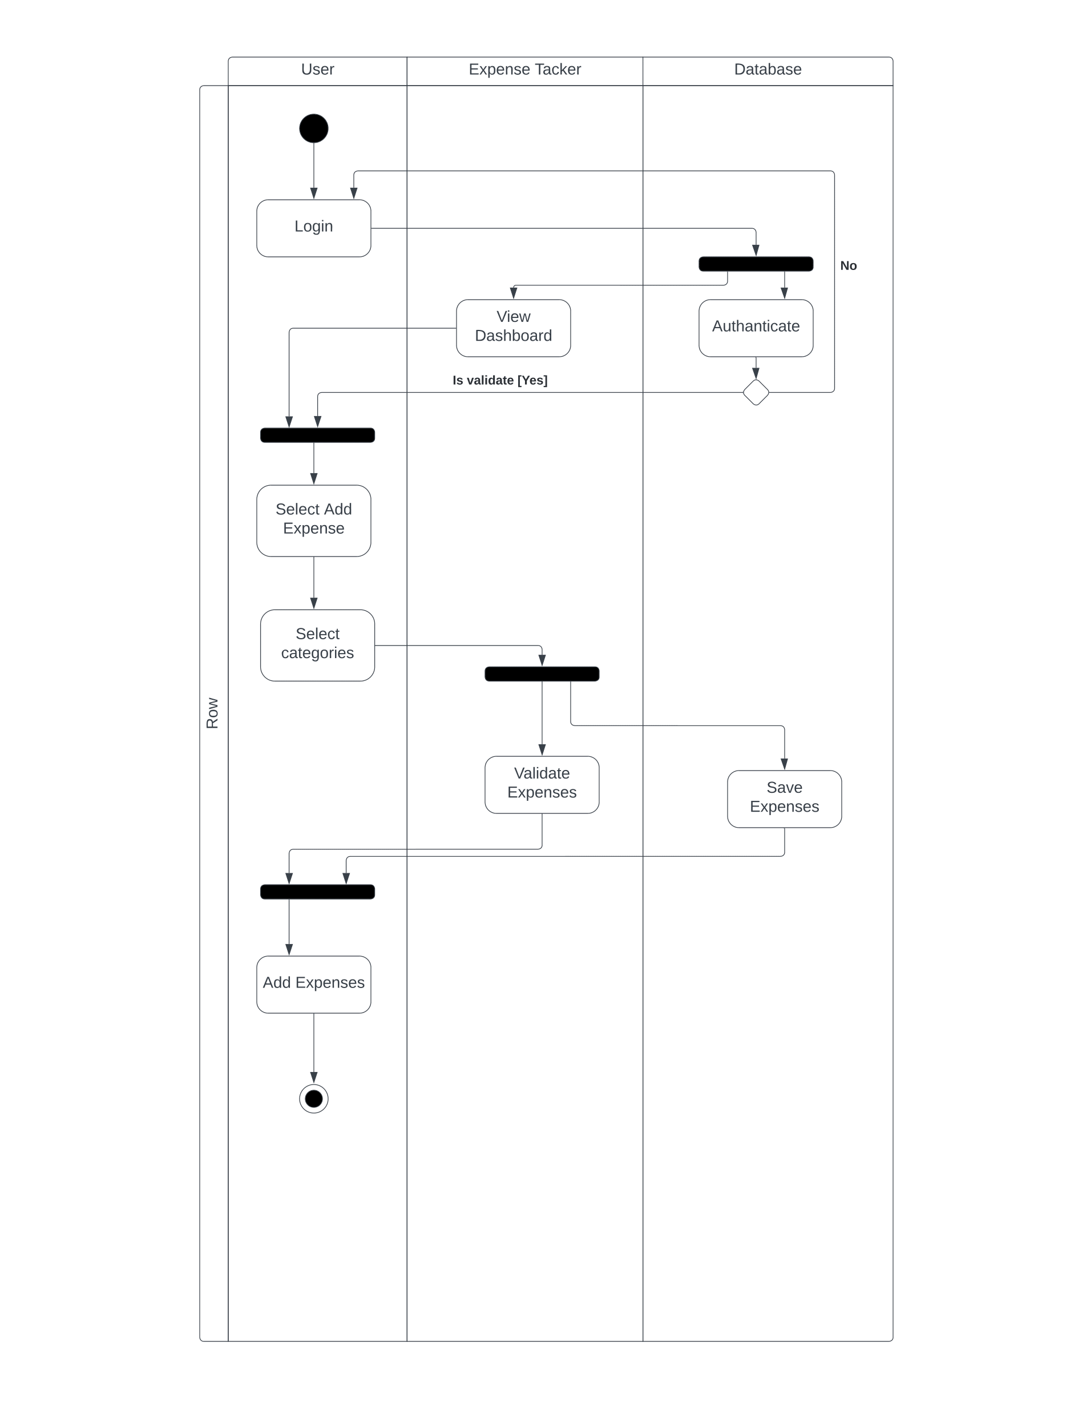

*Figure 18: Activity diagram – Add expenses*

*Figure 19: Activity diagram – View report*

**5.4 Sequence Diagrams**

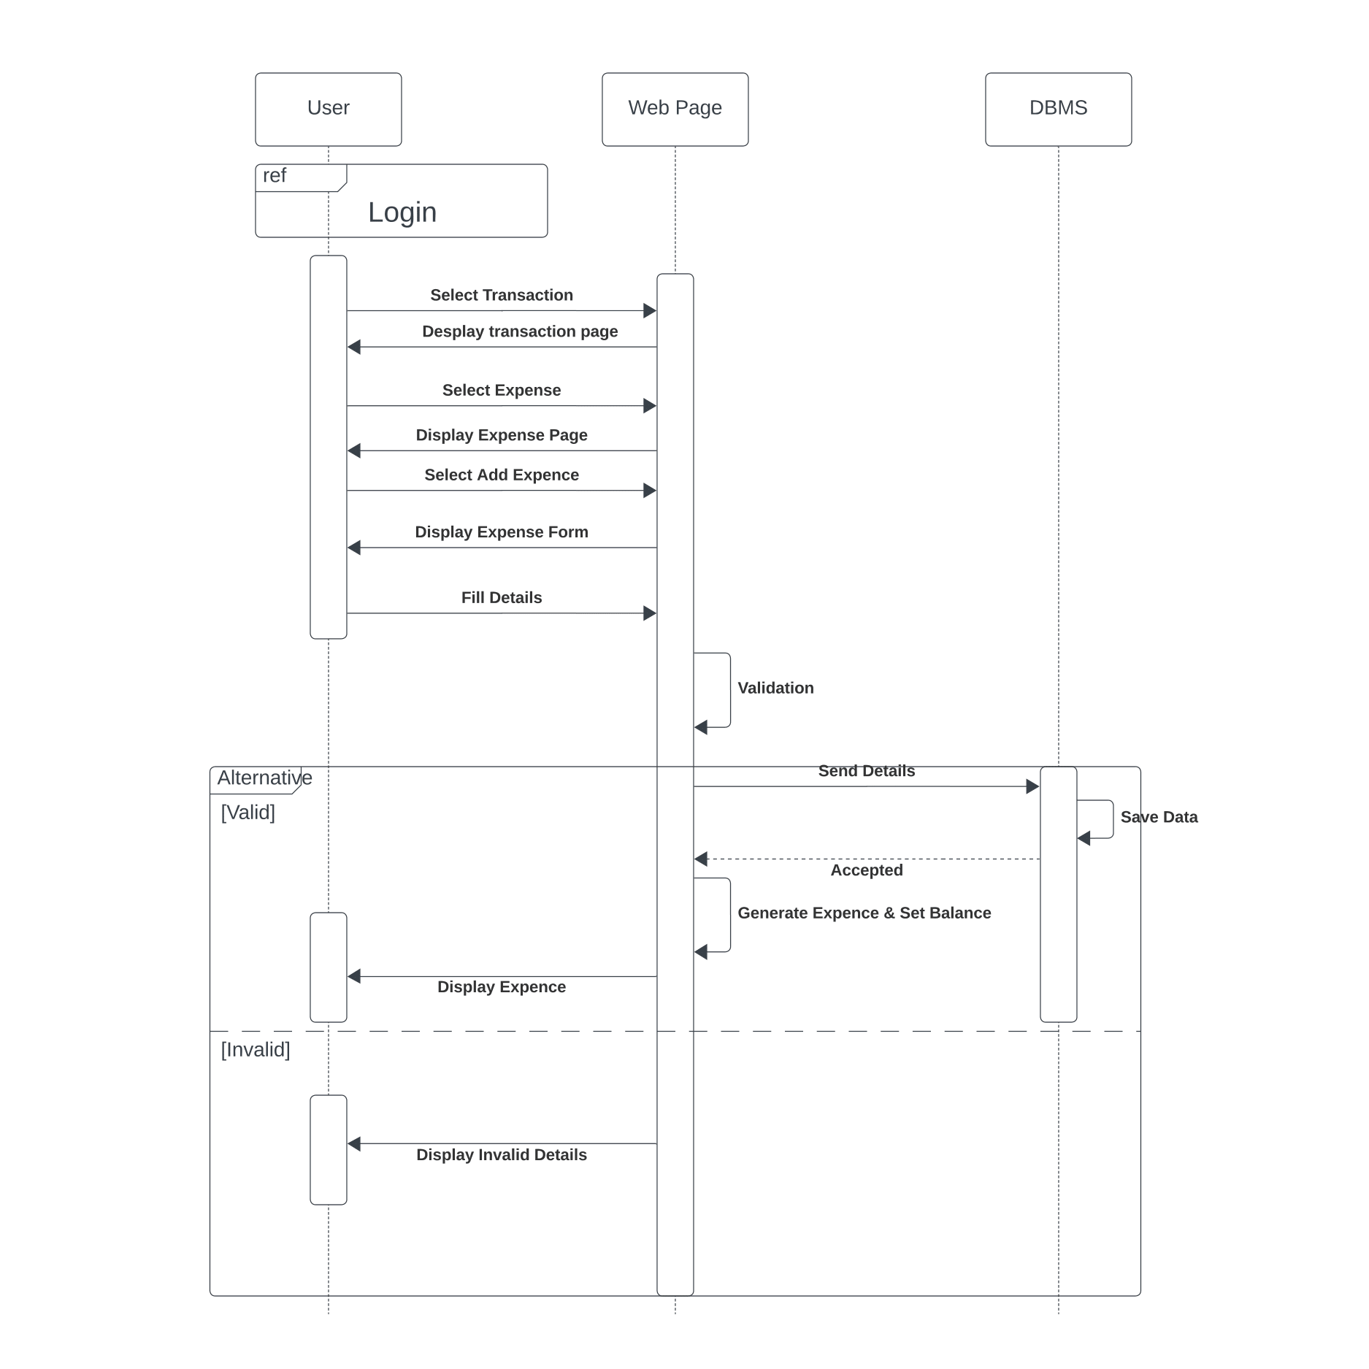

*Figure 20: Sequence diagram – Add expenses*

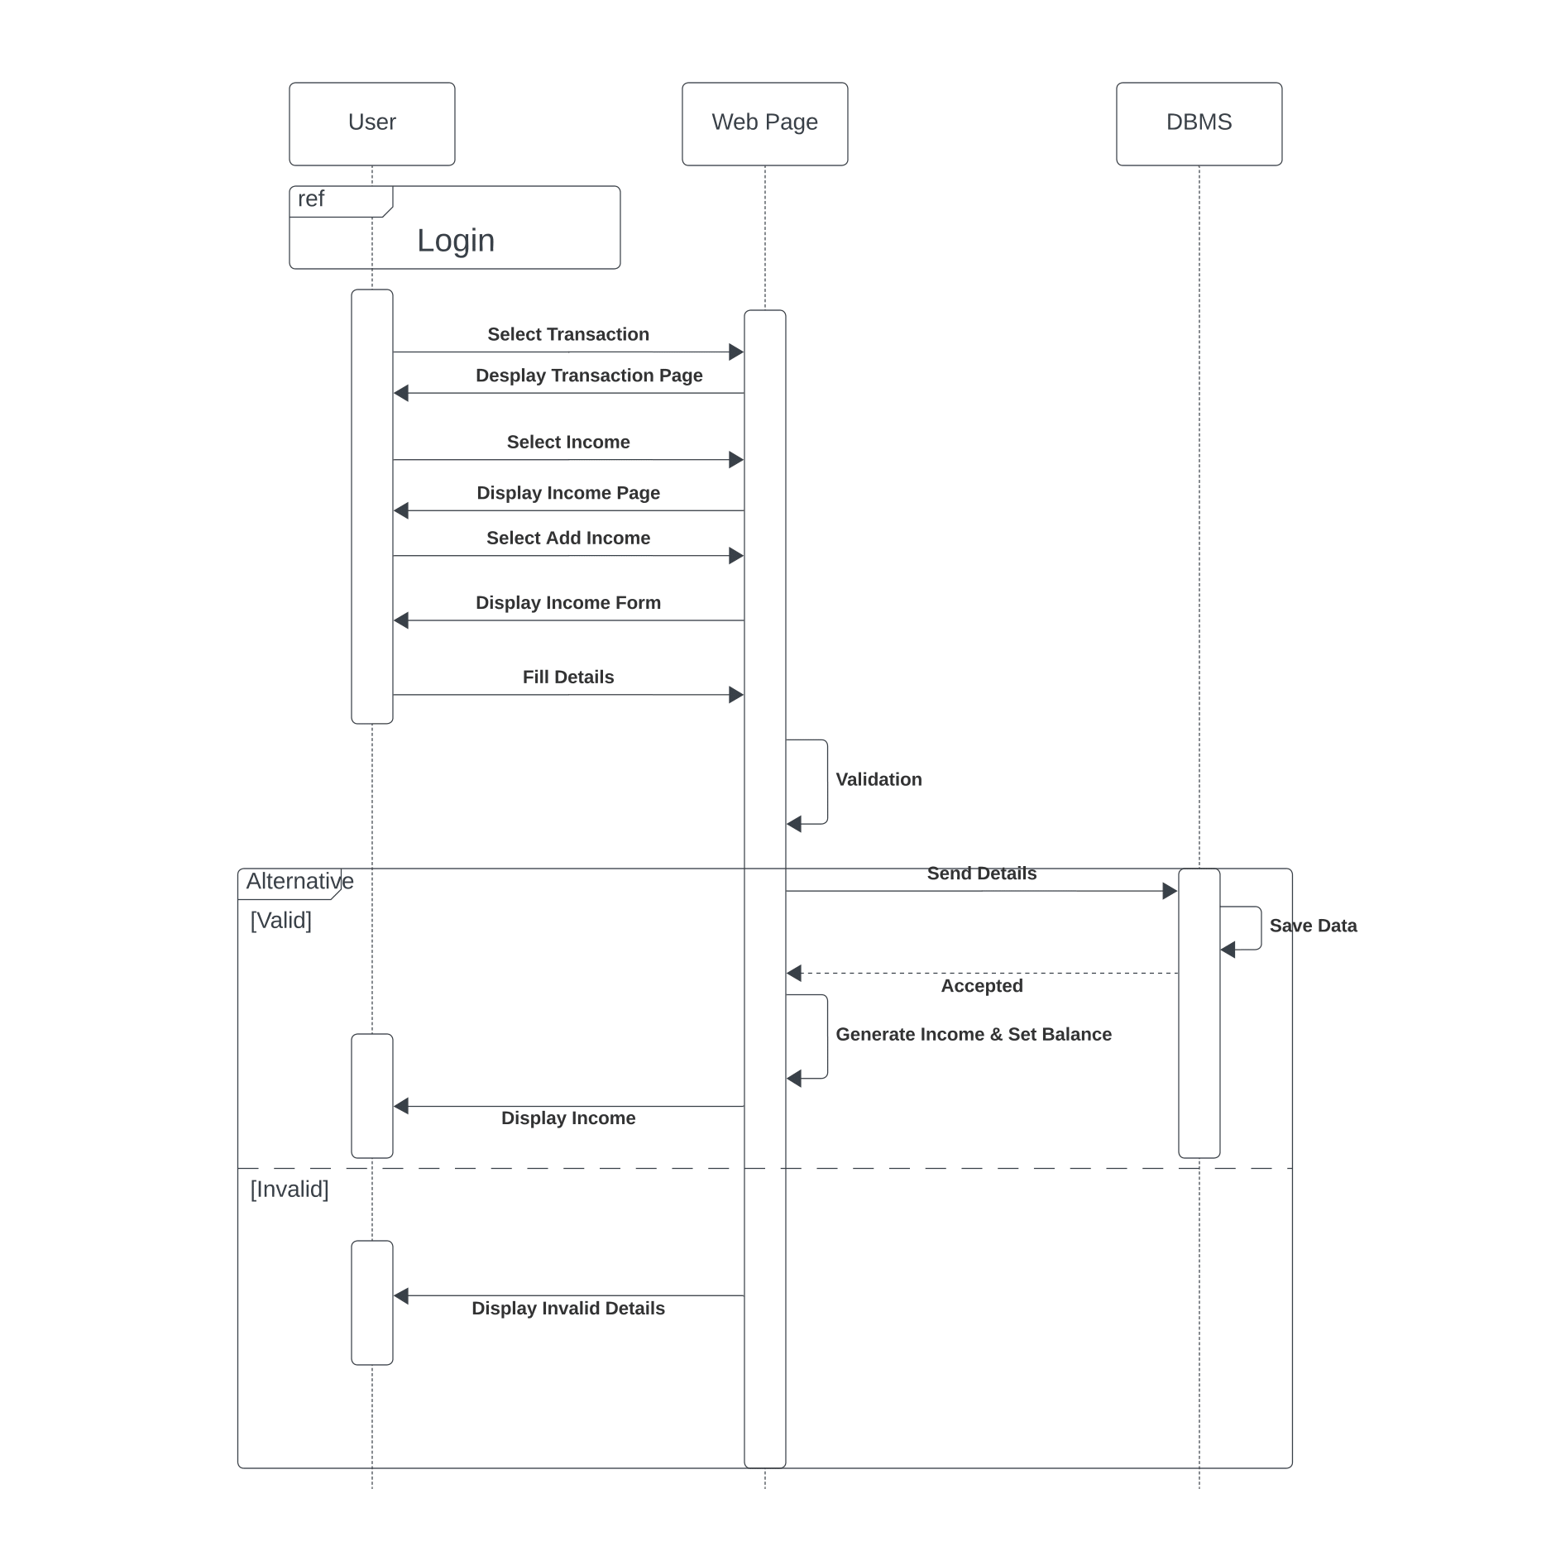

*Figure 21: Sequence diagram – Add incomes*

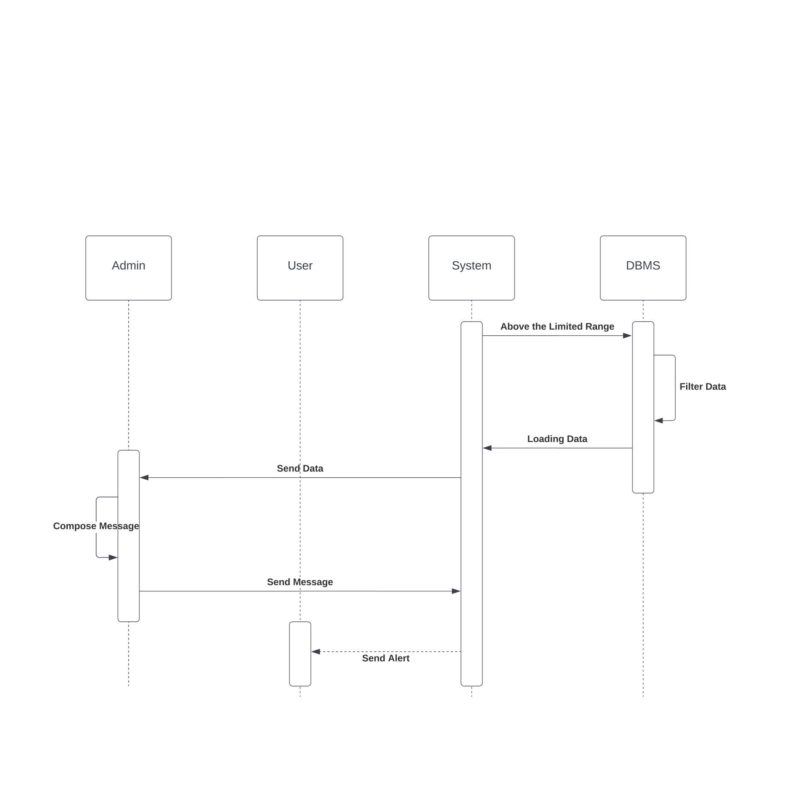

*Figure 22: Sequence diagram – Send alert*

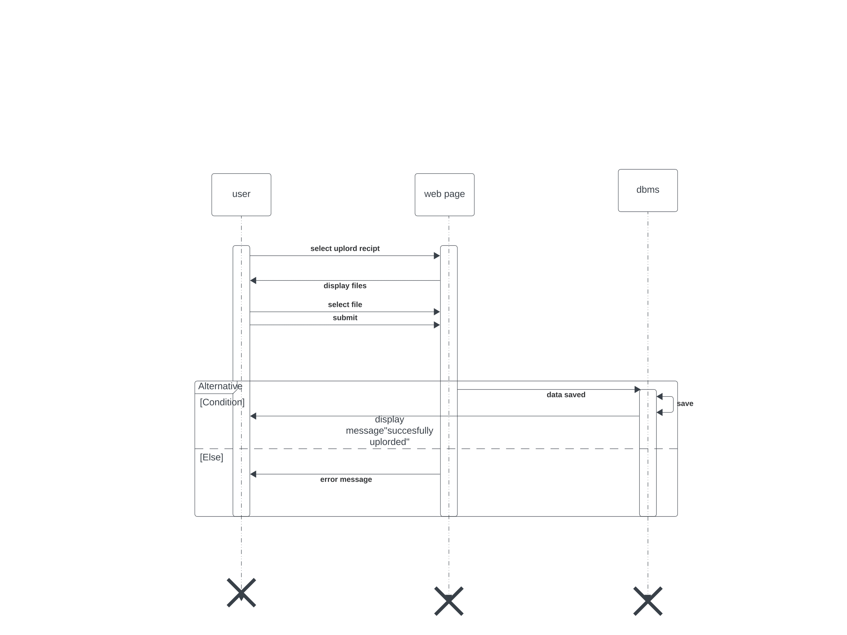

*Figure 23: Sequence diagram – Upload receipt*

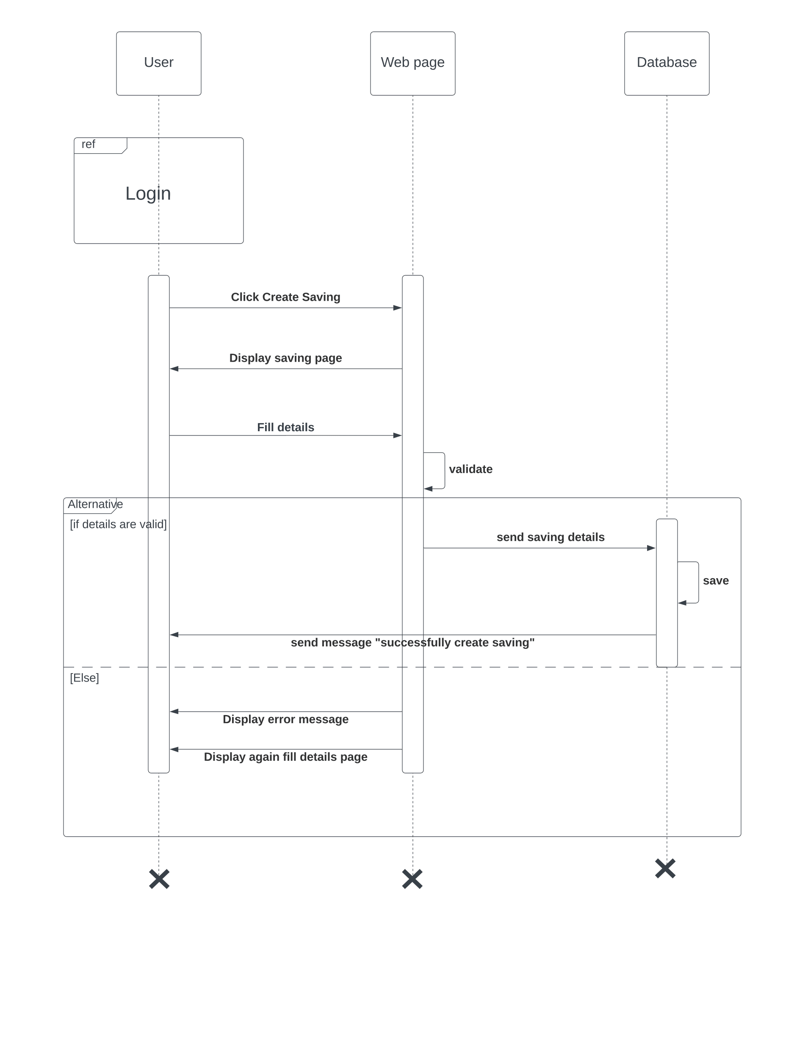

*Figure 24: Sequence diagram – Create savings*

*Figure 25: Sequence diagram – Download report*

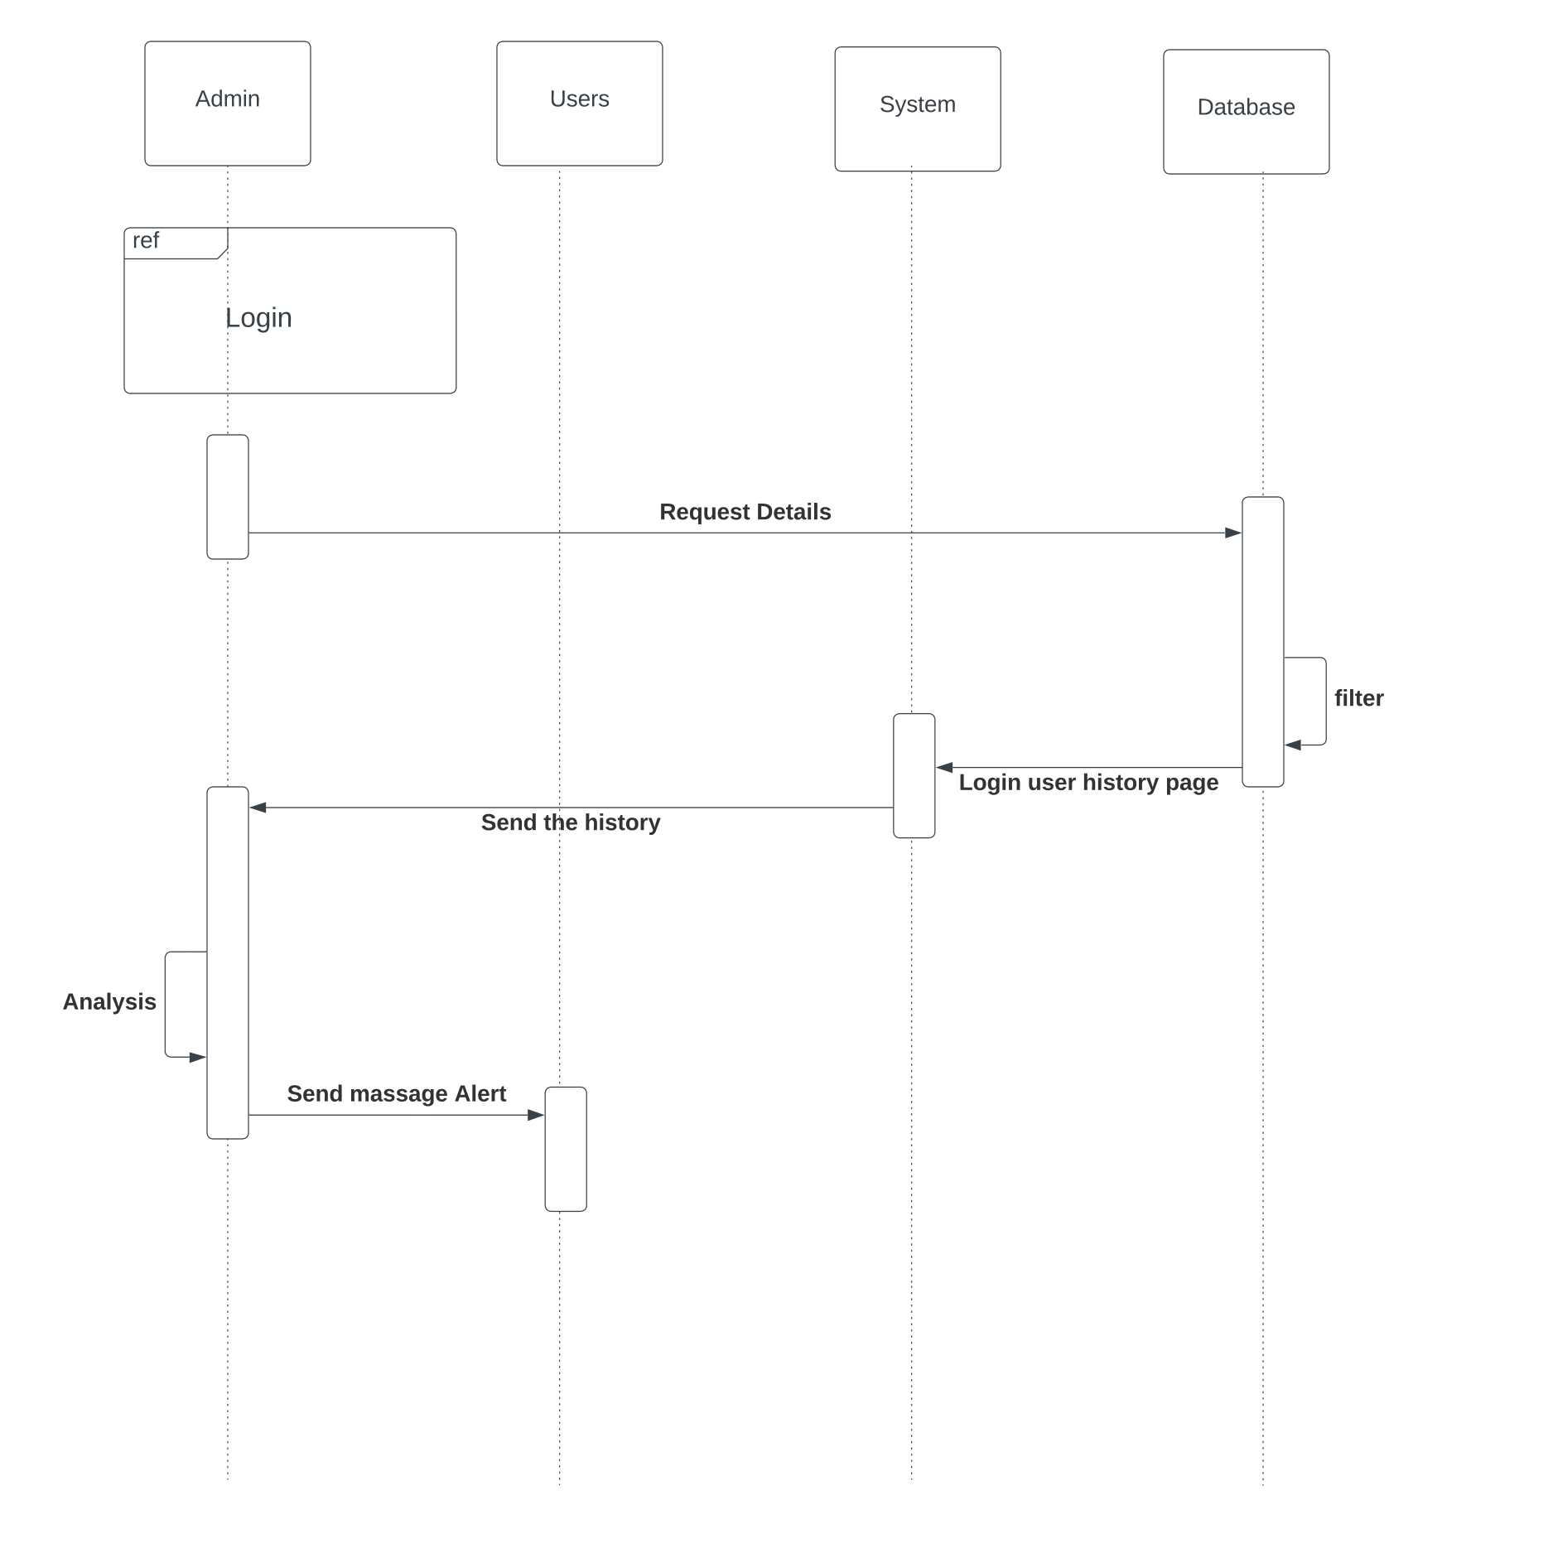

*Figure 26: Sequence diagram – Manage user*

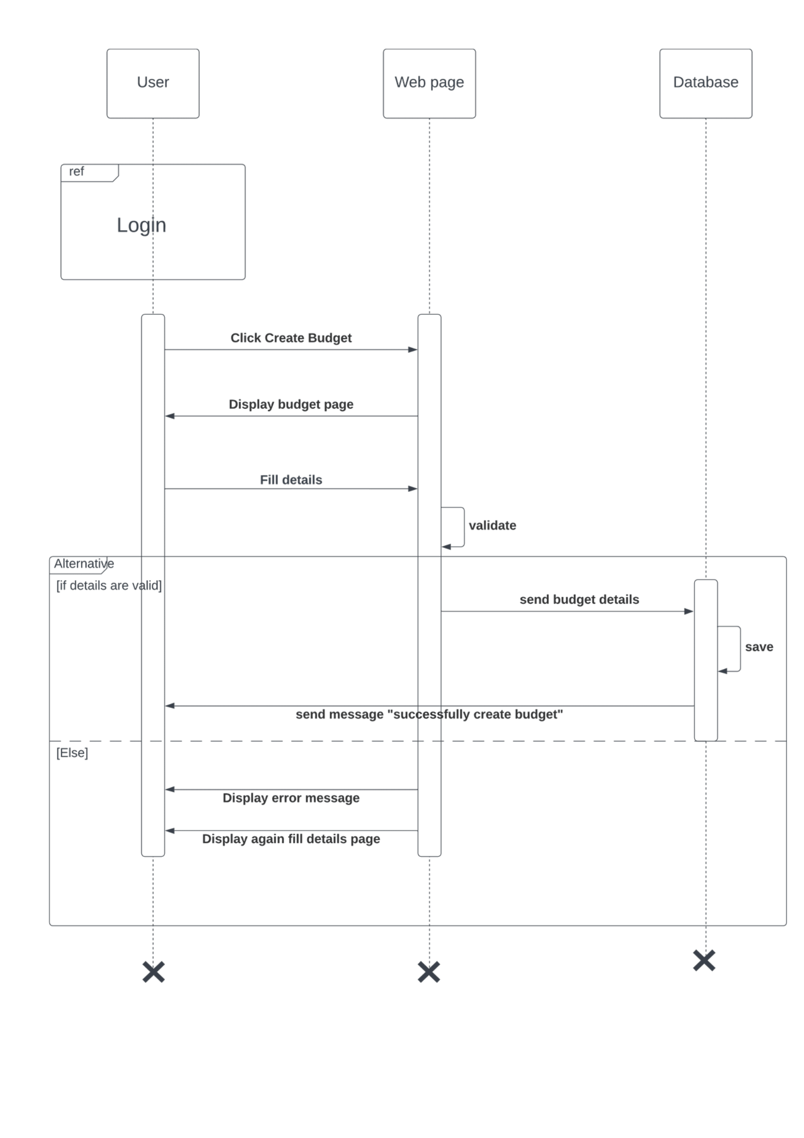

*Figure 27: Sequence diagram – Create budget*

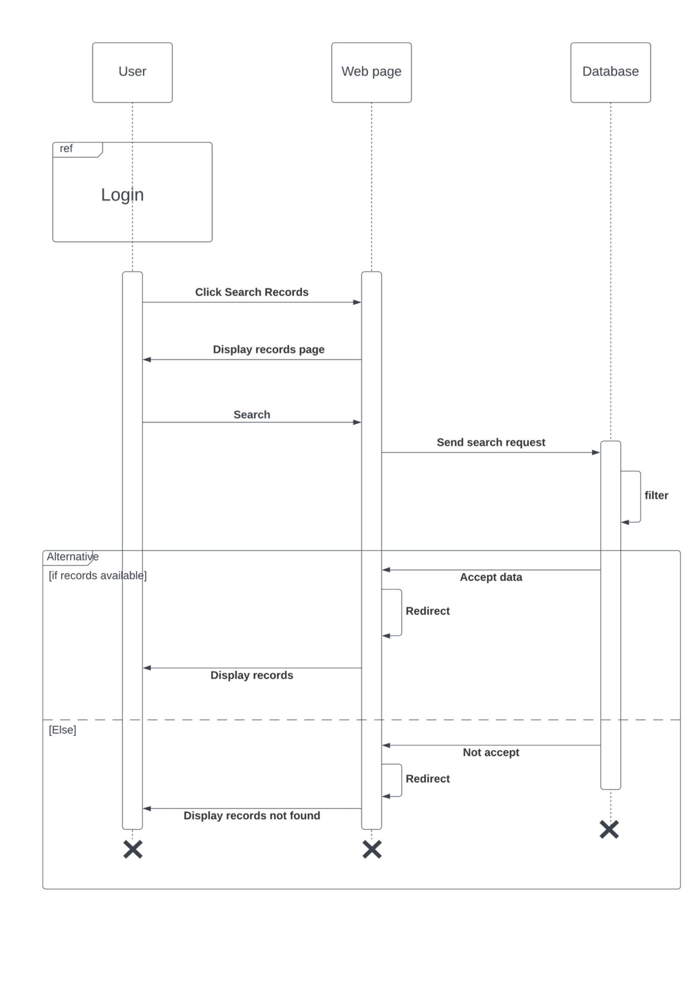

*Figure 28: Sequence diagram – Search records*

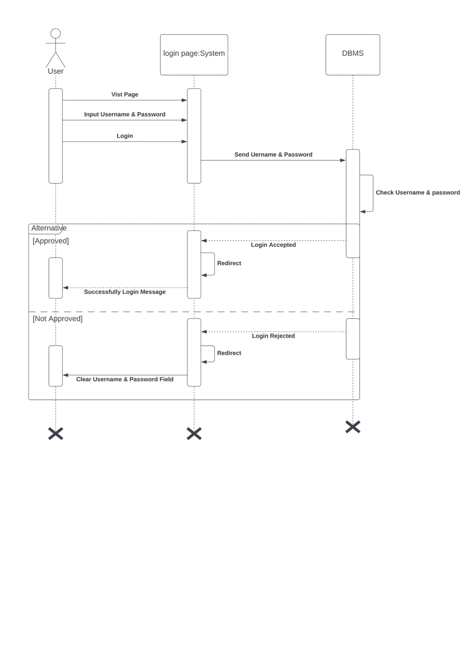

*Figure 29: Sequence diagram – Login*

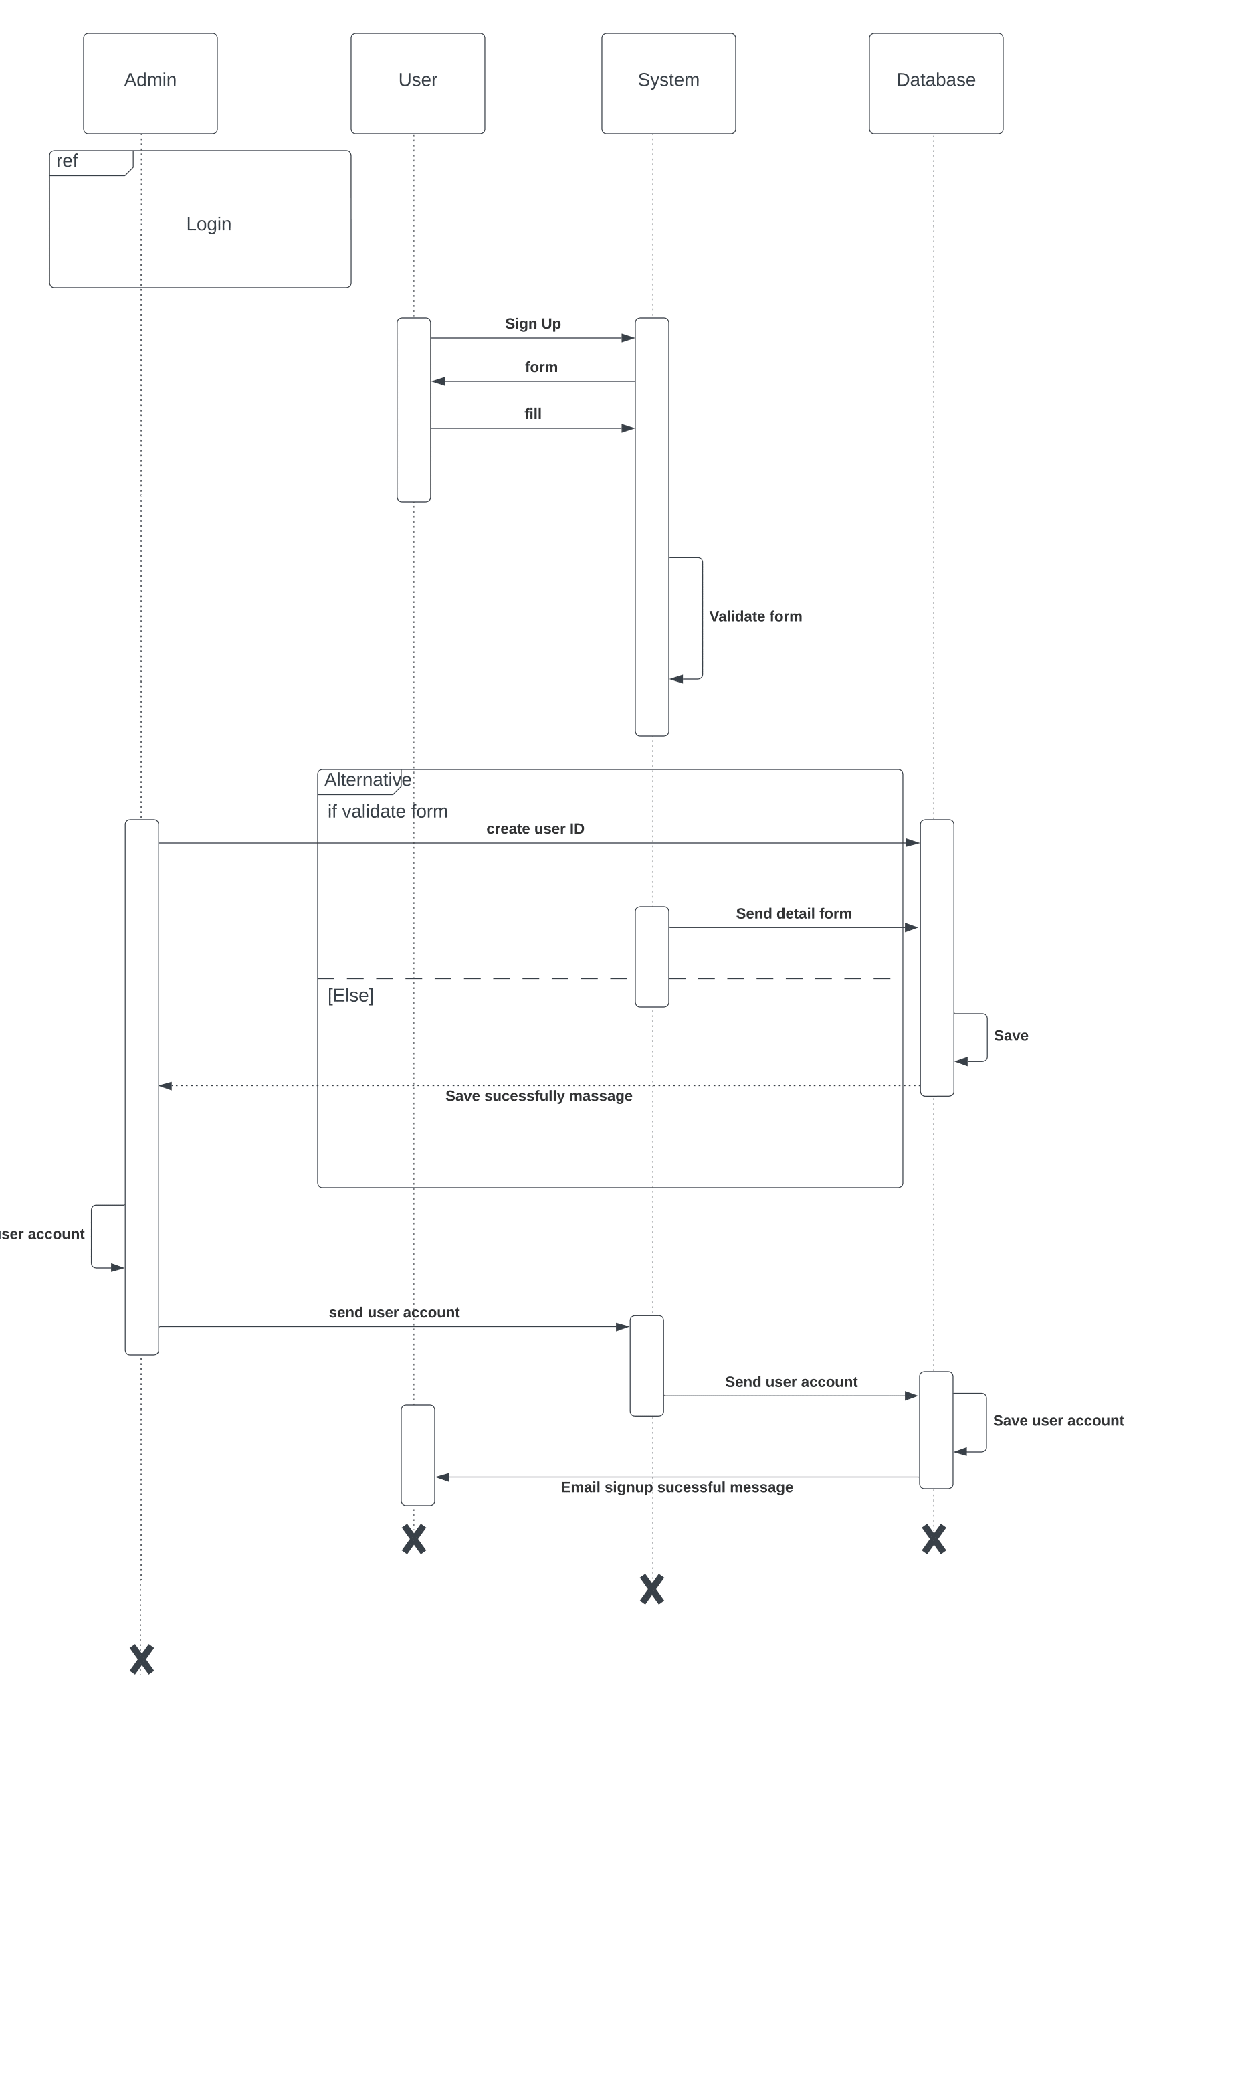

*Figure 30: Sequence diagram – Create user*

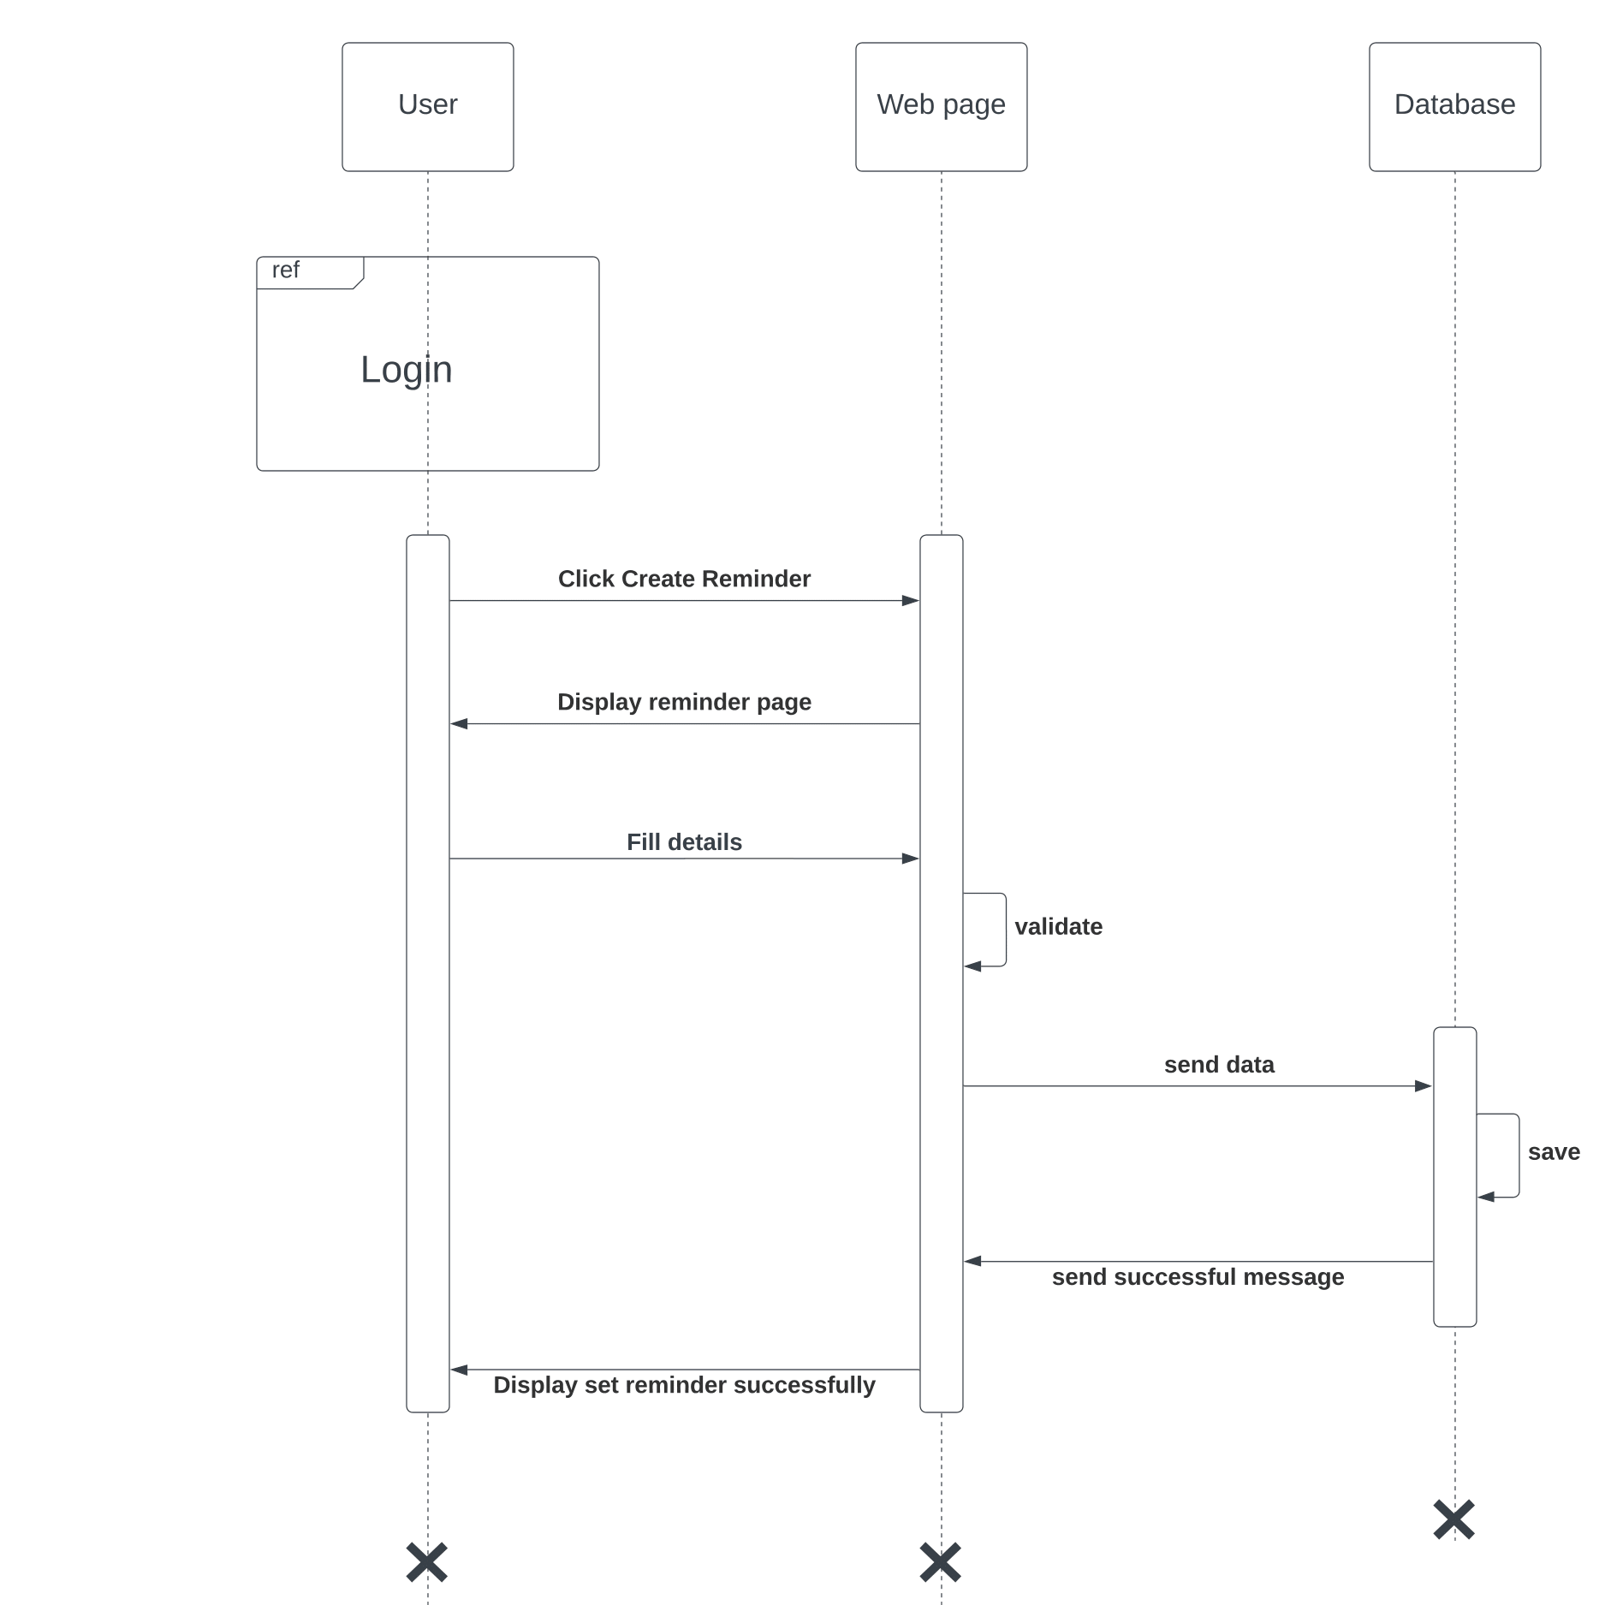

*Figure 31: Sequence diagram – Create reminder*

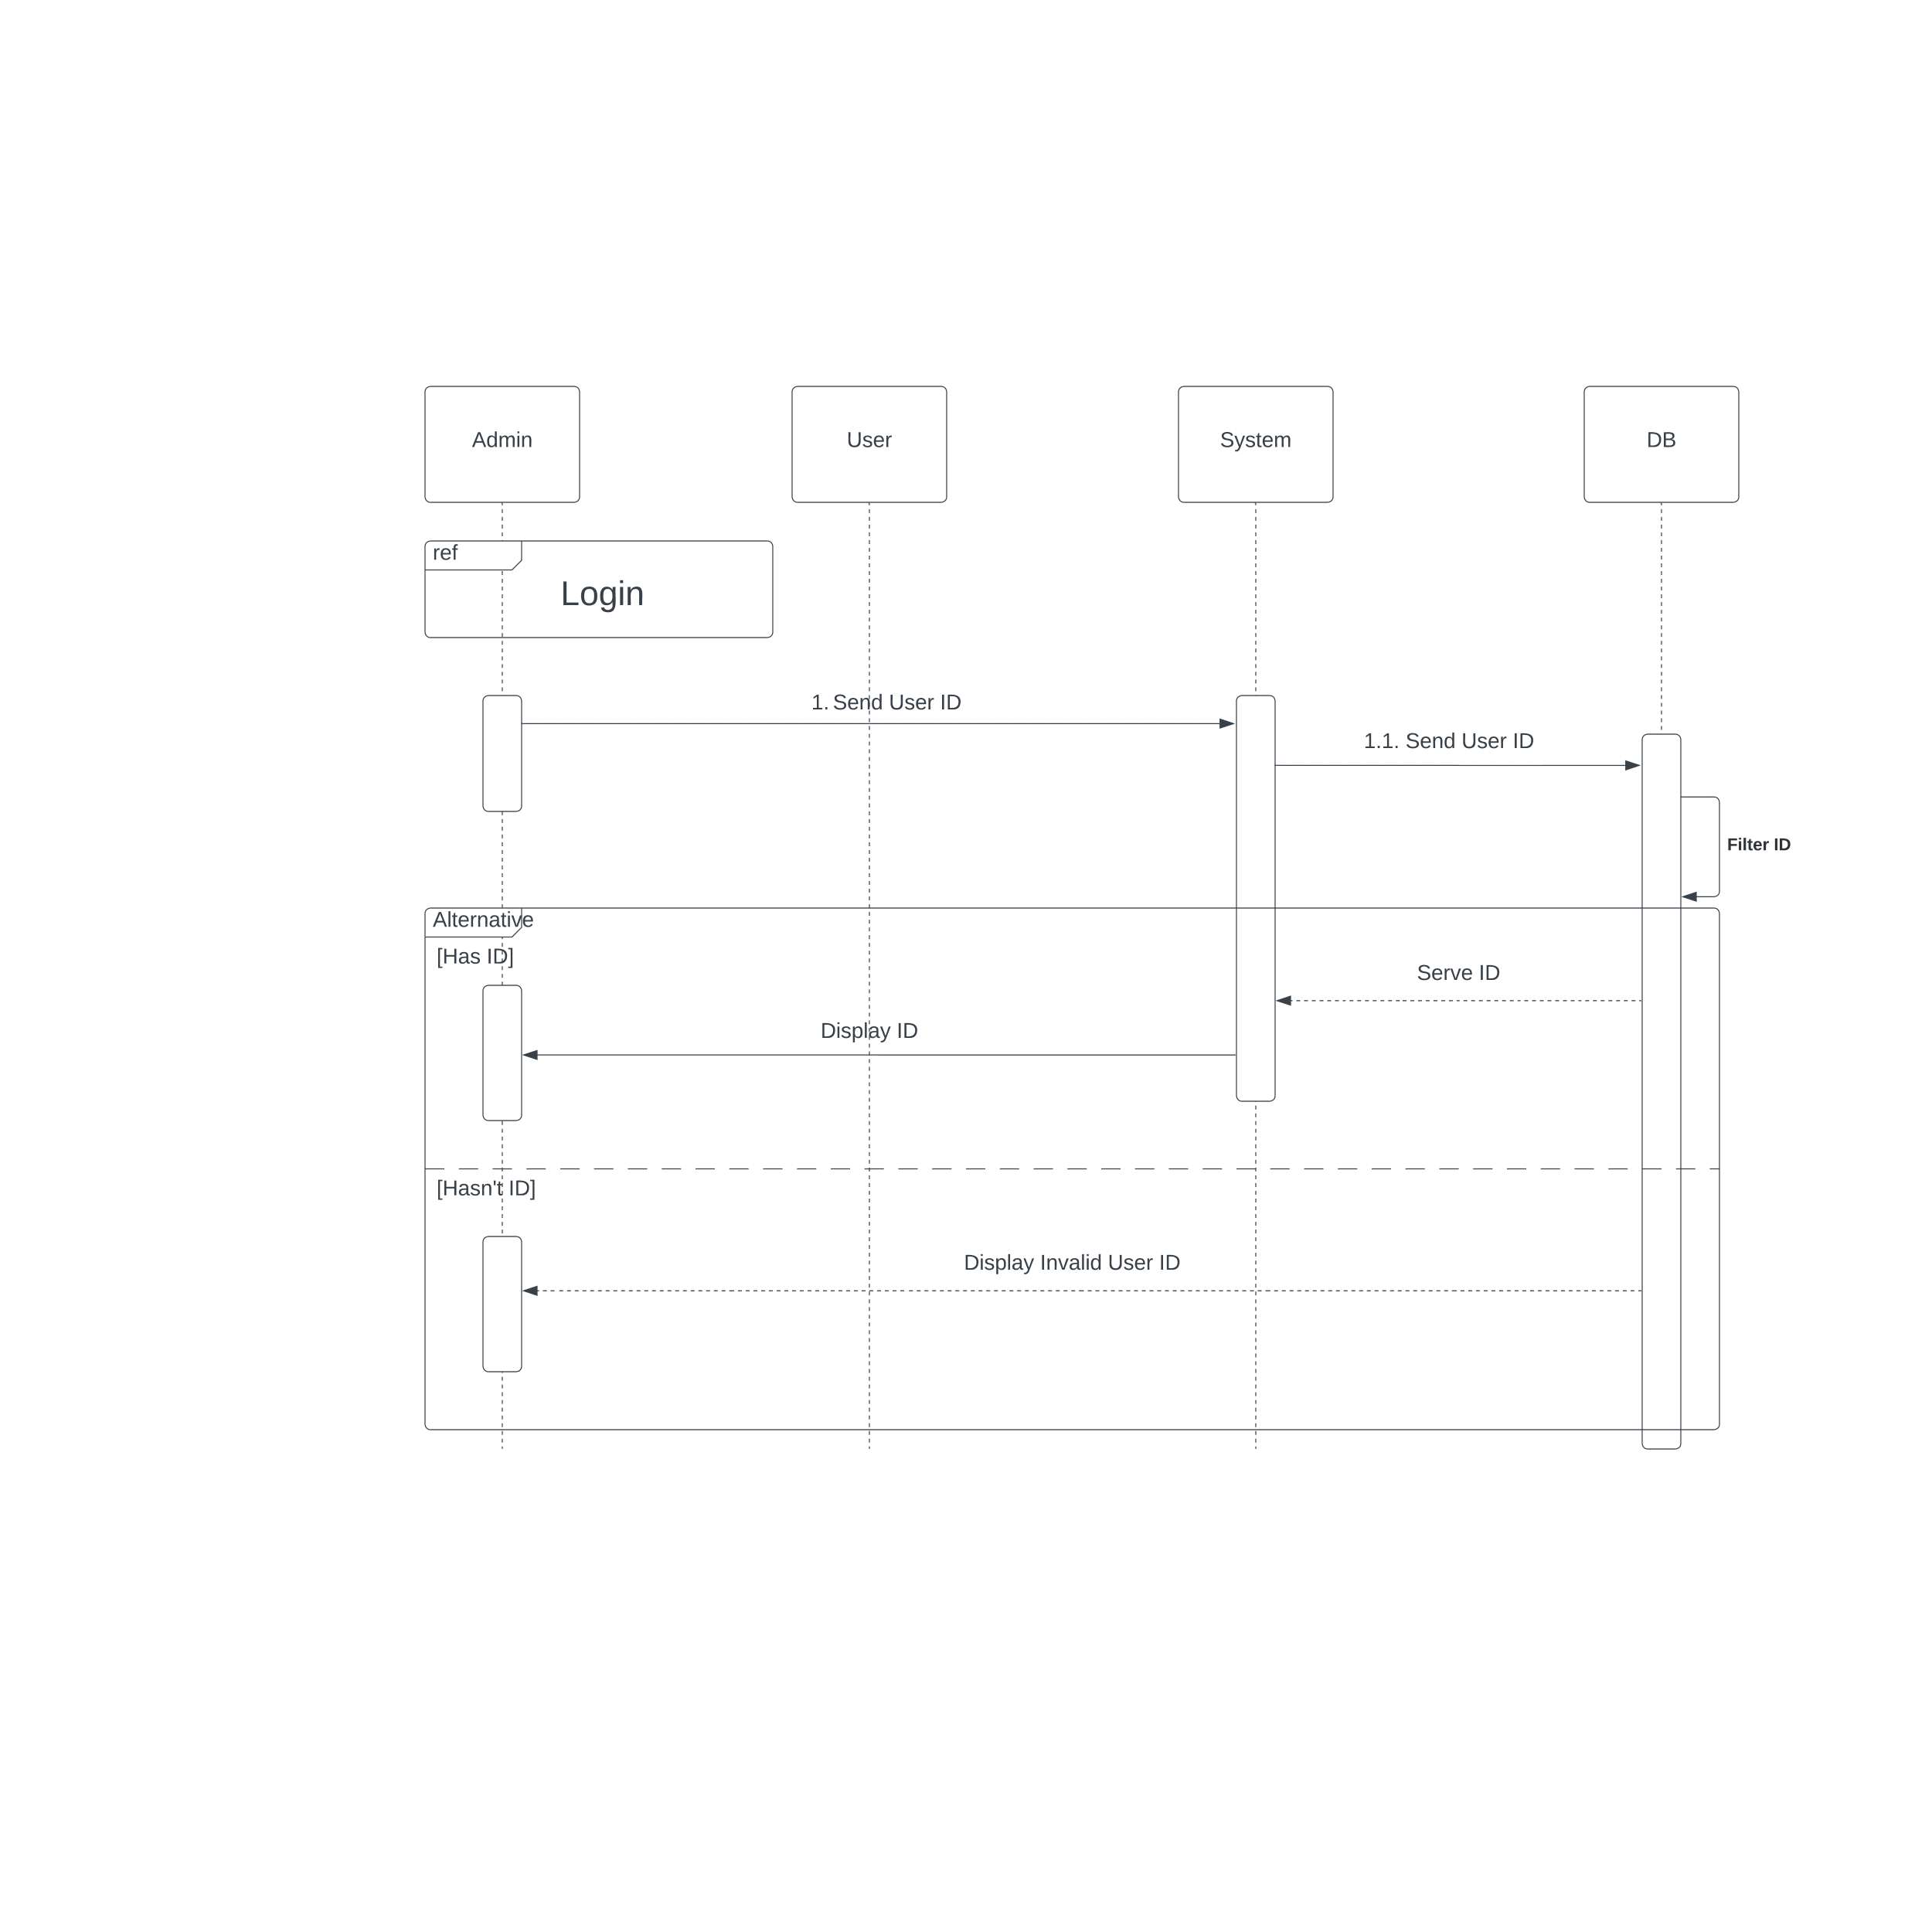

*Figure 32: Sequence diagram – Search user*

*Figure 33: Sequence diagram – View transaction*

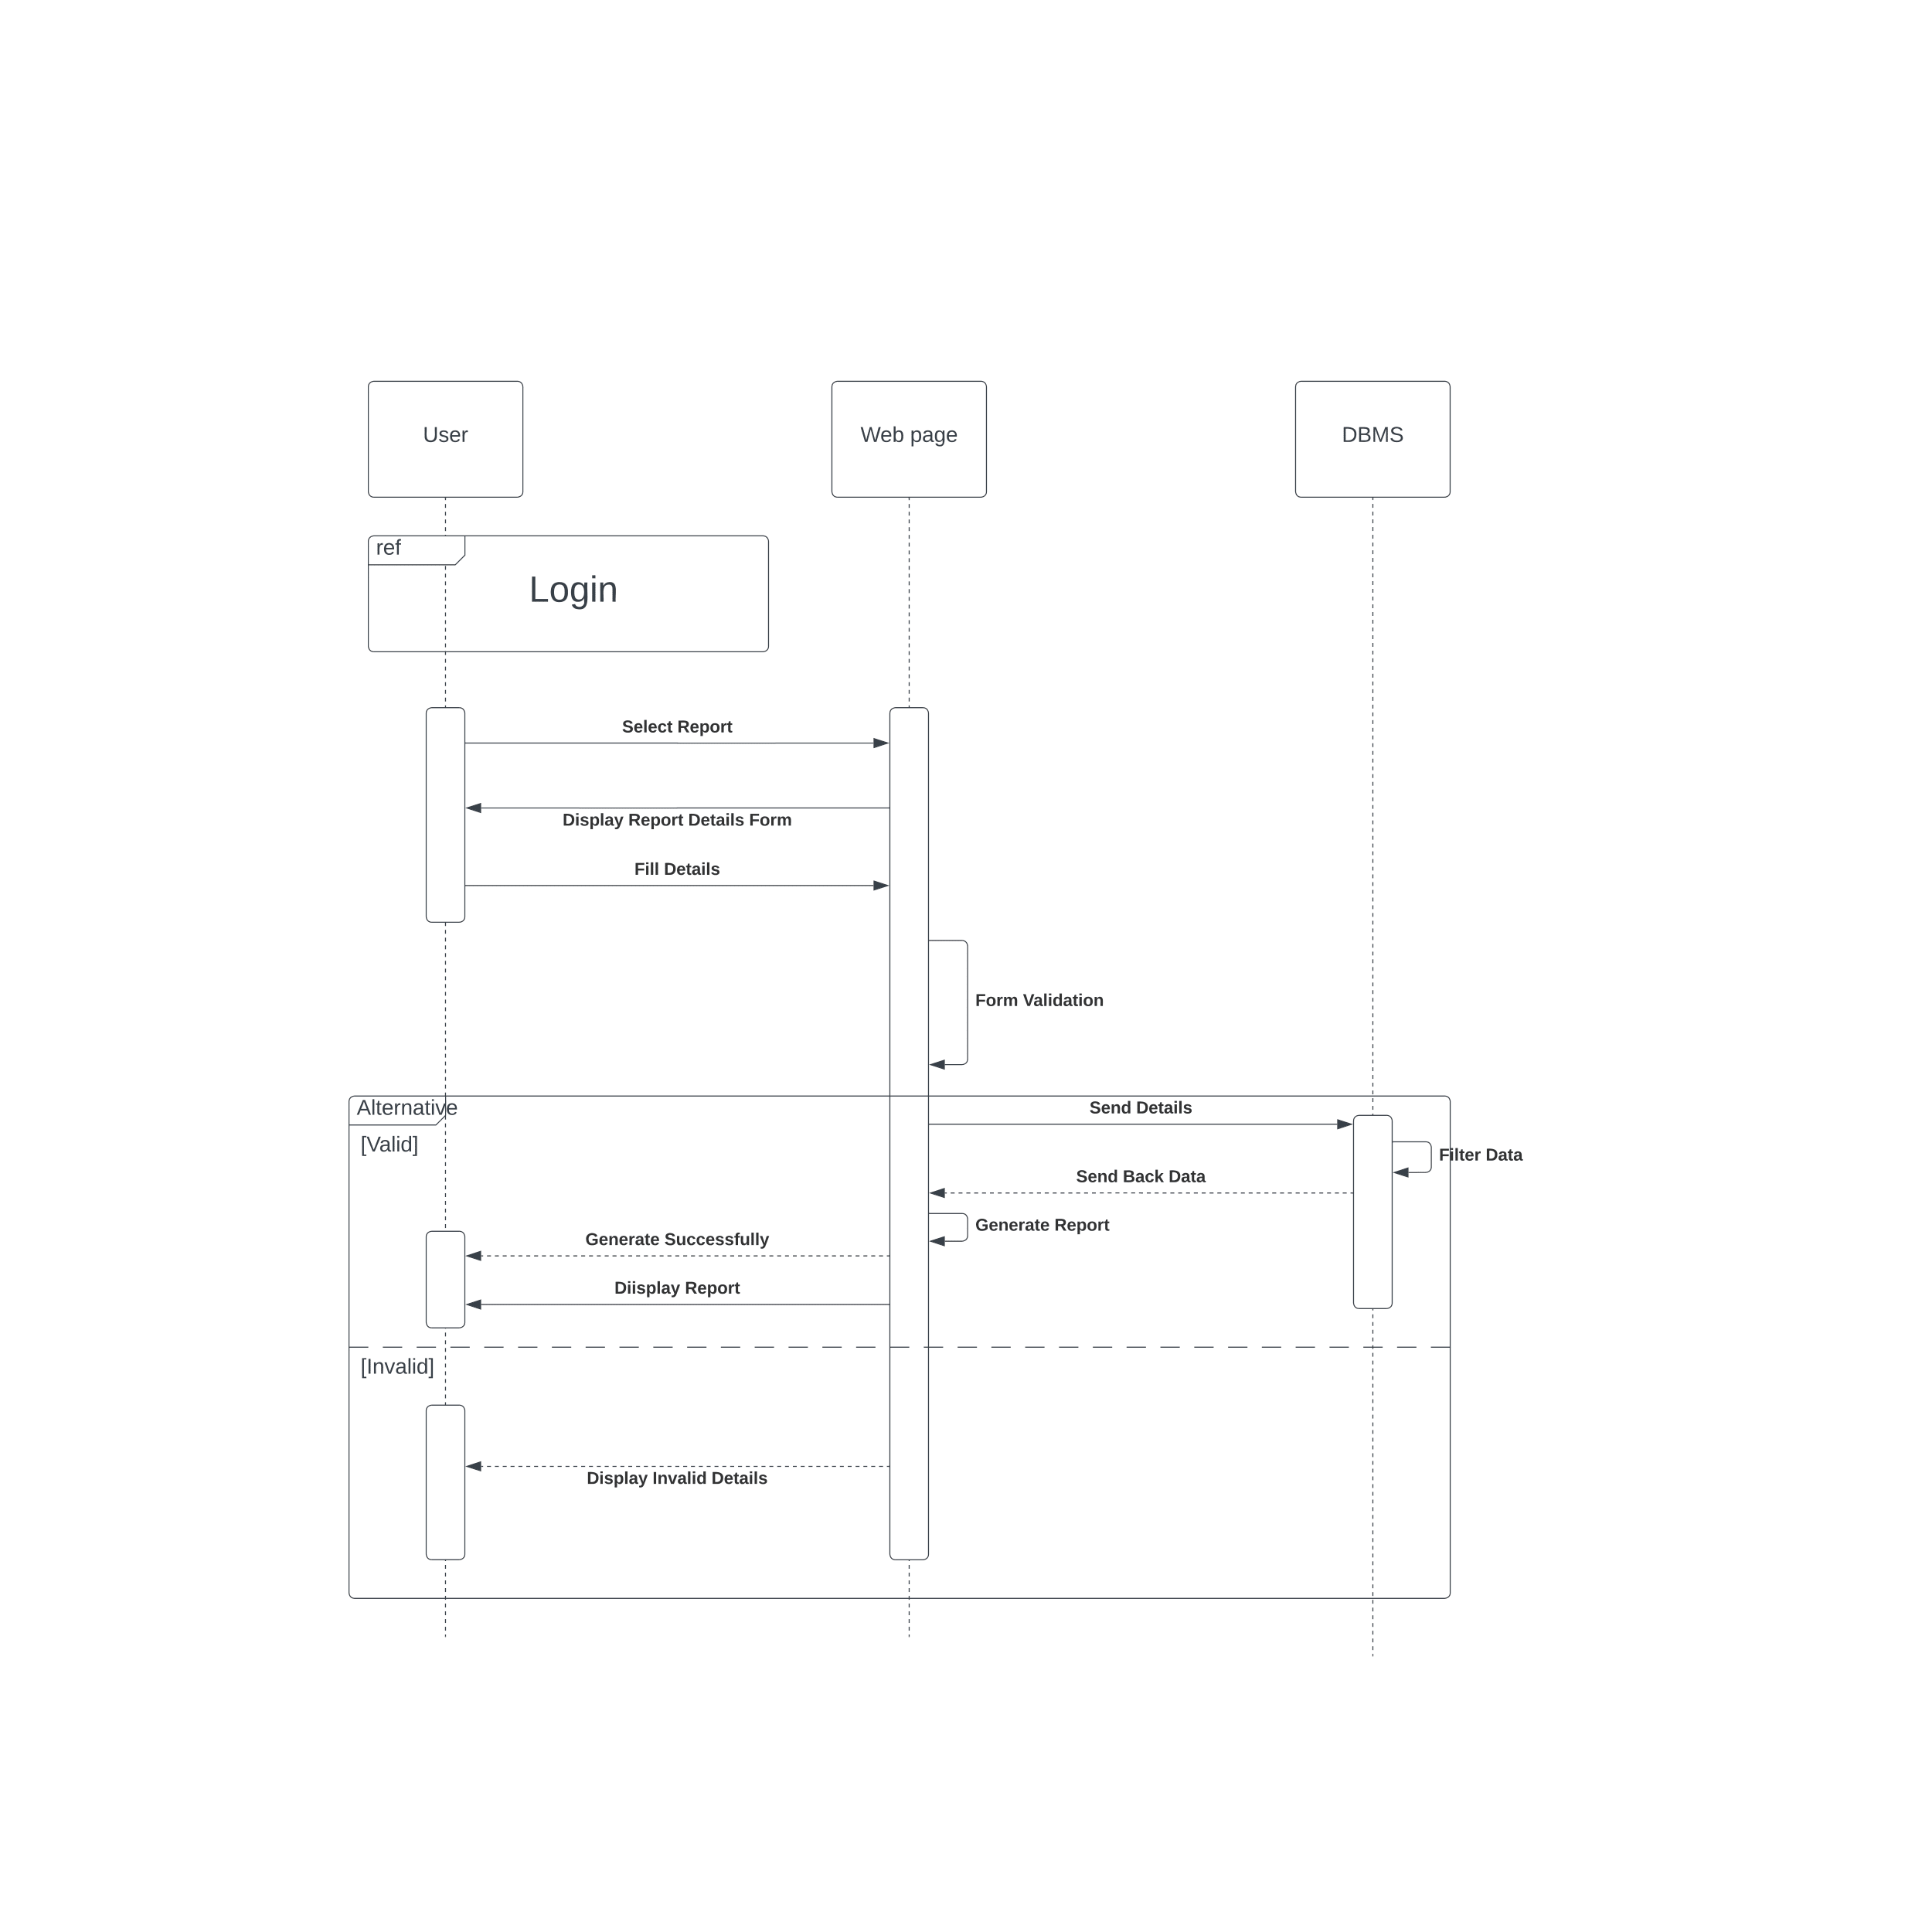

*Figure 34: Sequence diagram – View report*

**5.5 ER Diagram**

**Chapter 6 Implementation**

**Chapter 7 Discussion**

**7.1 Introduction**

This chapter briefly discusses the evaluation and testing of our project, how our solution differs from similar works done by others, and the further work of our project.

**7.2 Evaluation and Testing**

As we are still in the early stage of creating our project, we have not yet conducted any evaluations or tests on any part of it. This means currently we have not assessed the functionality, reliability, or any other performance.

**7.3 How our solution differs from similar works done by others**